# Payment Tracking in Banking

# Project Overview:

# The Payment Tracking in Banking CRM is a Salesforce-based solution designed to track loan repayment management for banks. Traditionally, banks relied on manual processes to track EMI schedules, overdue payments, and loan recovery, which led to errors, delays, and poor customer experience. This CRM resolves those issues by providing centralized loan and payment records, automated reminders for customers, recovery workflows, dashboards. It leverages Salesforce automation tools like validation rules, workflows. Creating custom objects for Loan, Payment and recovery provide a structure way to manage financial data and secure sharing rules, field level security protect sensitive customer and financial information. The system ensures timely payment tracking, efficient collections, and transparent communication with customers through email.

# Objectives:

# To build a secure, automated Salesforce CRM that centralizes loan, payment and recovery management while Improving customer experience through timely remainders.

# Enabling role-based access so managers, officers, and agents can securely view only the data relevant to them.

# Providing real-time dashboards and reports for monitoring loan status, overdue amounts, and recovery performance.

# Ensuring customer communication via email alerts for due dates, approvals, and recovery updates.

# Supporting business efficiency by minimizing manual work, improving compliance, and enhancing customer satisfaction.

# Phase 1: Problem Understanding & Industry Analysis

**Requirement Gathering**

* Identify gaps in manual payment tracking.
* Understand issues in sending timely payment reminders.

# Stakeholder Analysis

* Customers, bank staff, recovery agents, and managers.
* Focus on their roles and interaction with the payment system.

# Business Process Mapping

* Map repayment lifecycle:

due date → reminder → payment → overdue → recovery.

* Visualize processes for loan and EMI repayments.

# Industry-specific Use Case Analysis

* EMI reminders, loan repayments, credit card dues monitoring.
* Streamline overdue and recovery workflows.

# AppExchange Exploration

* Research payment reminder.
* Identify ready-made apps to speed up implementation.

# Phase 2: Org Setup & Configuration

**Salesforce Editions**

* + Use Developer Edition for initial development and testing.
  + Plan for Enterprise Edition for production banking workflows**.**

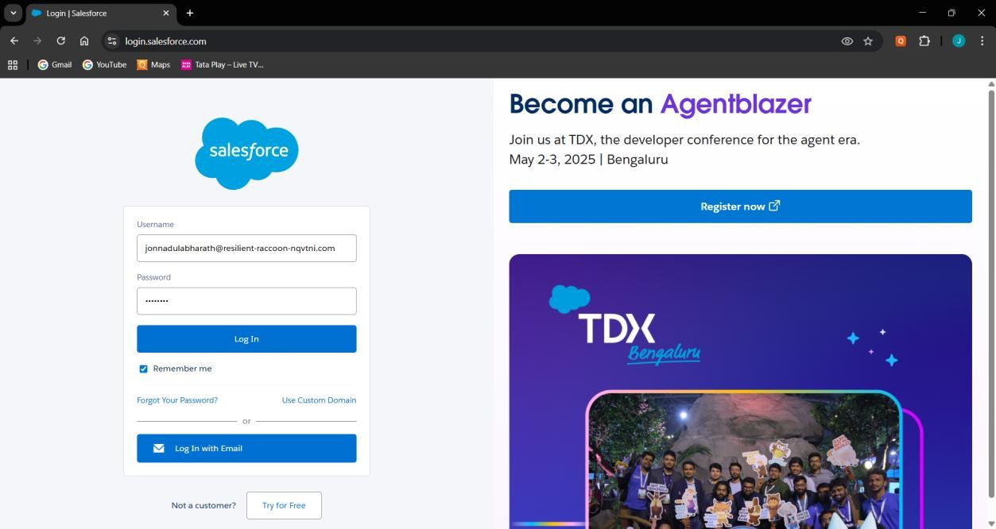

# Company Profile Setup

* + Set Company Name, Currency (INR/USD), and Time Zone.
  + Configure organization-wide defaults.

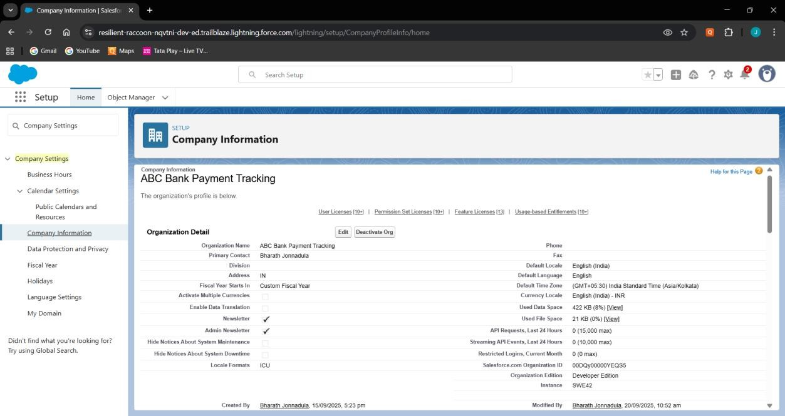

# Business Hours & Holidays

* + Define working hours (e.g., Mon–Sat, 9 AM–6 PM).
  + Add holidays like Independence Day and Diwali.

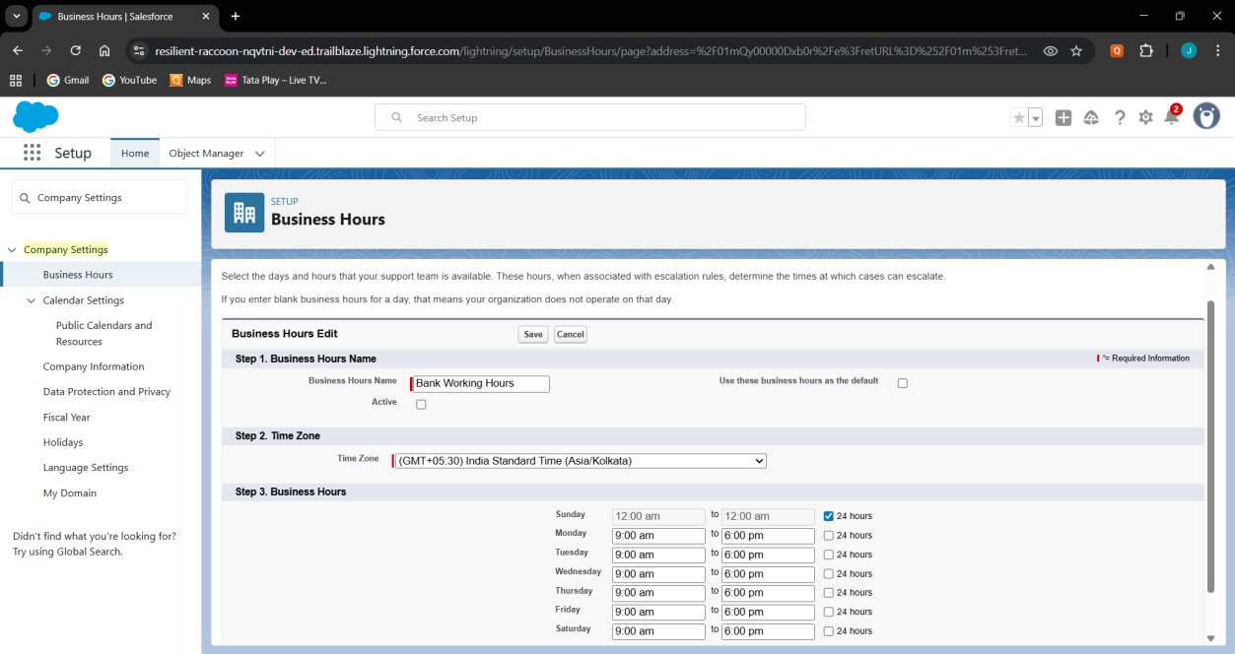

# Fiscal Year Settings

* + Use standard Jan–Dec fiscal year or custom if needed.
  + Align with financial reporting requirements.

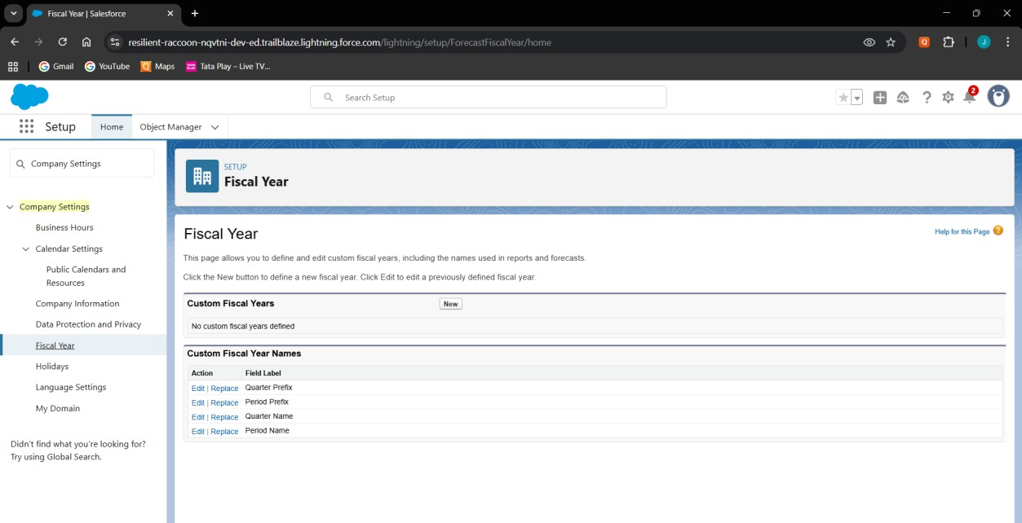

# User Setup & Licenses

* + Create Loan Officer, Recovery Agent, and Manager users.
  + 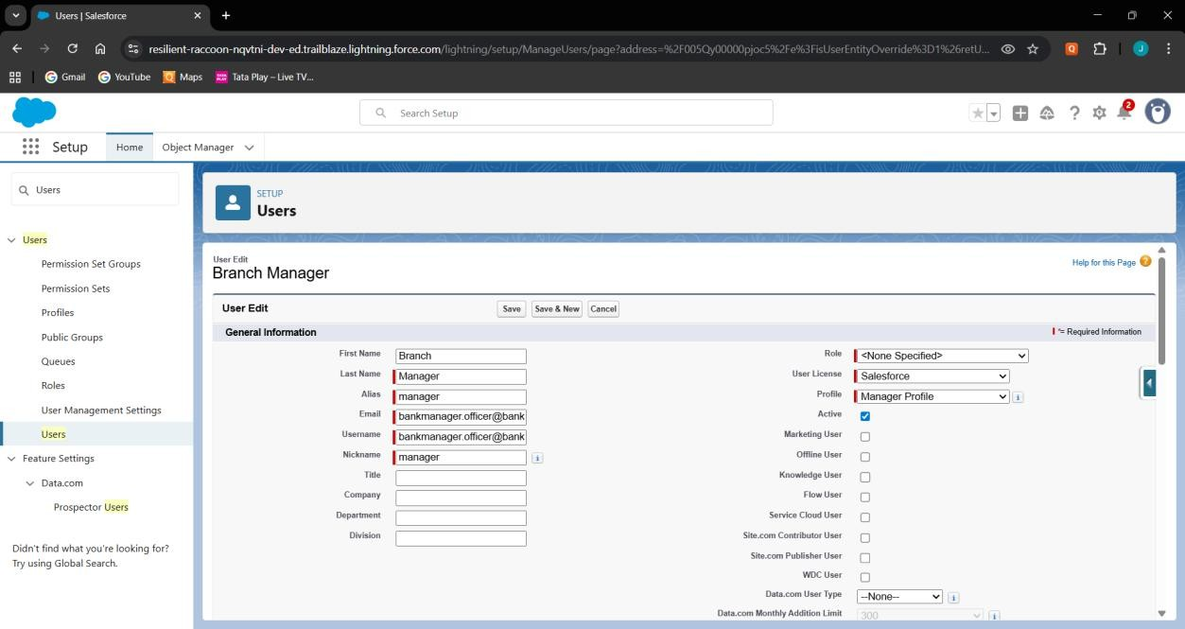Assign appropriate licenses (Salesforce / Salesforce Platform).

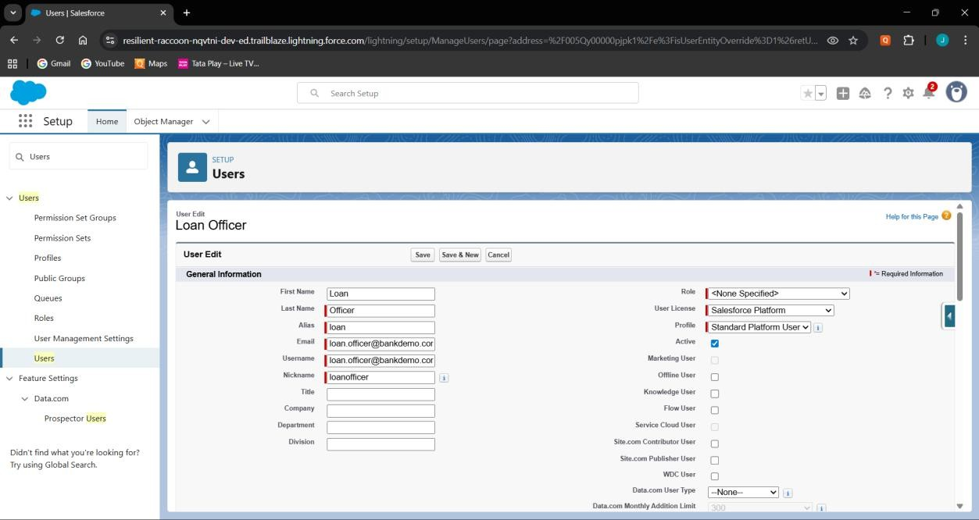

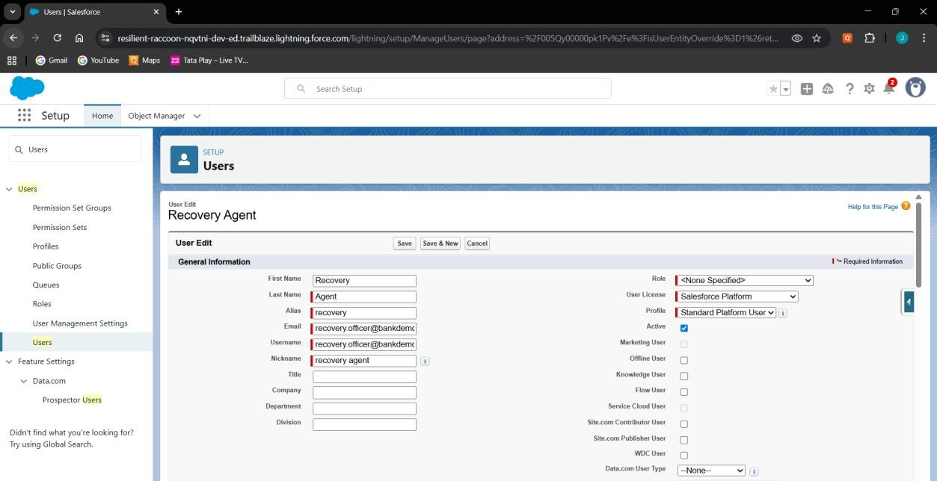

# Login Access Policies

* + Set session timeout to 30 minutes.
  + Enable login hours (8 AM–8 PM) for users.

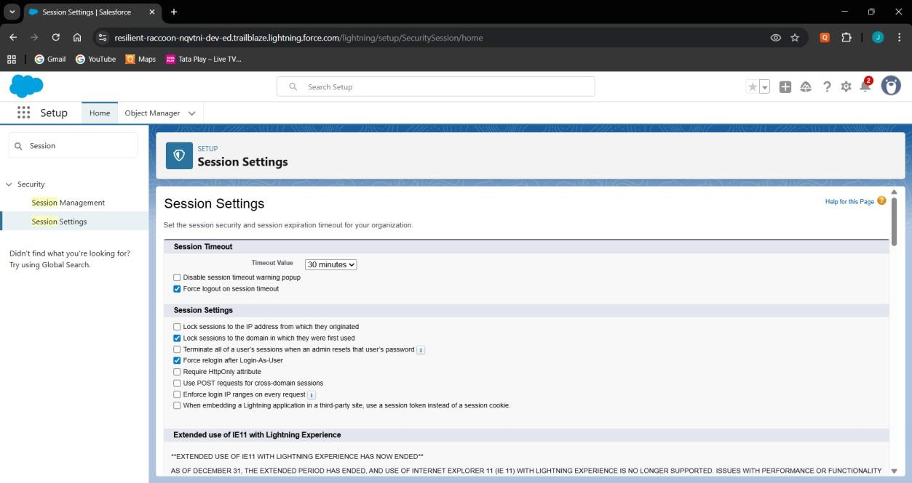

# Dev Org & Sandbox Usage

* + Use Developer Org for development and testing.
  + Plan sandbox usage for production-like testing later.

# Deployment Basics

* + Use SFDX commands to push/pull metadata.
  + Prepare for deployment via Change Sets or SFDX when ready.

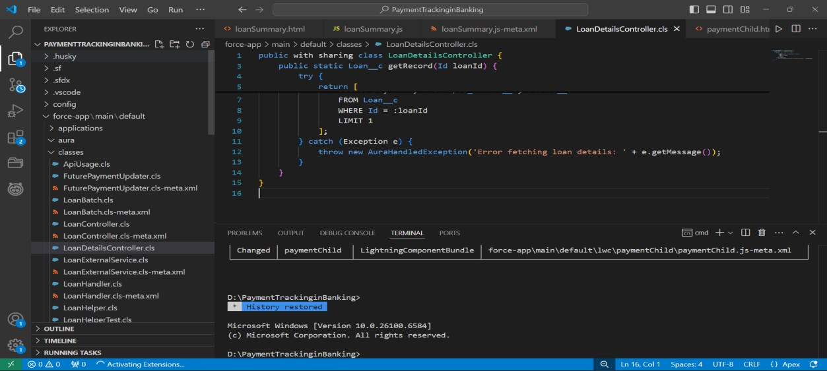

# Phase 3: Data Modeling & Relationships Standard & Custom Objects

* Use Account/Contact for Customers.
* Create custom objects: Loan, Payment, Recovery, Loan Agent Assignment (junction).

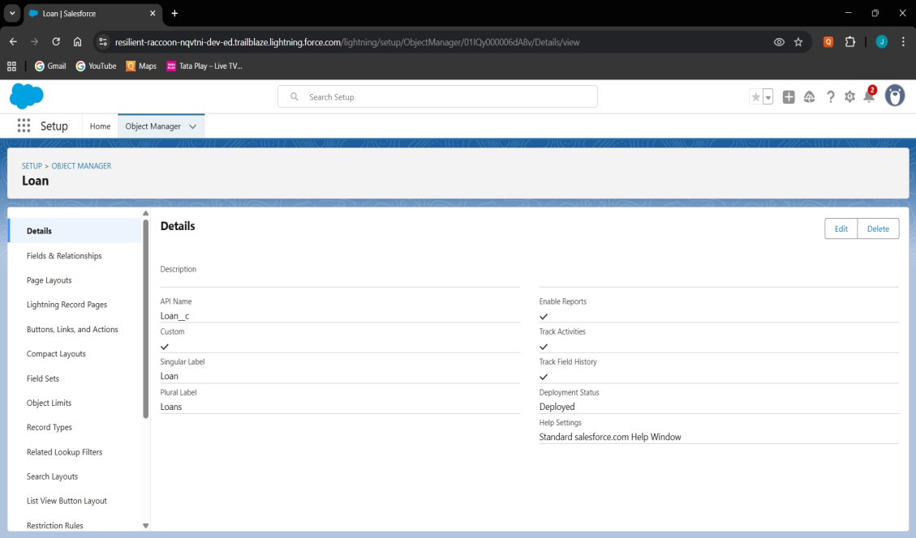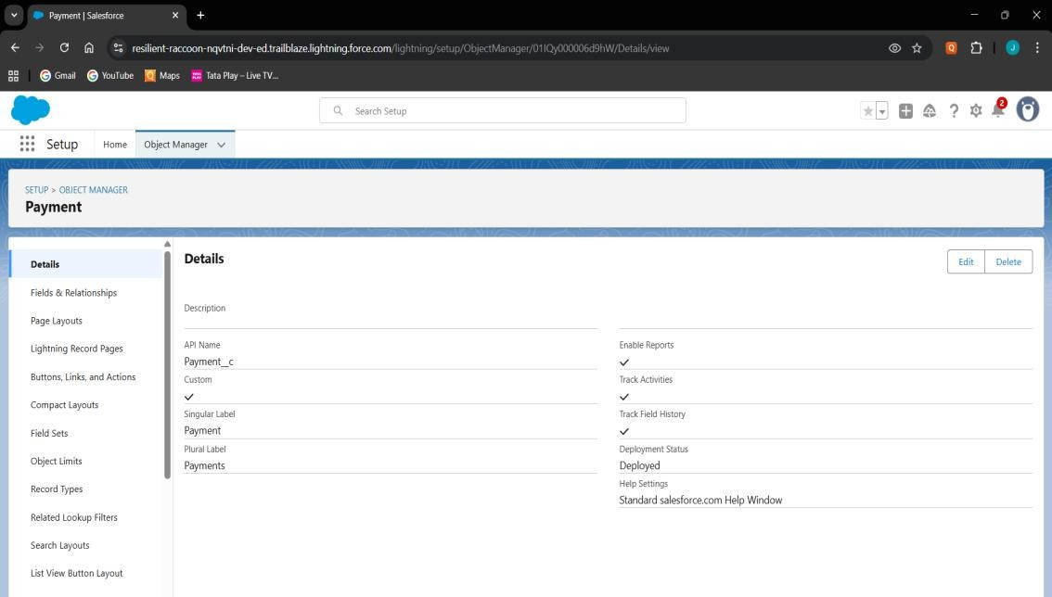

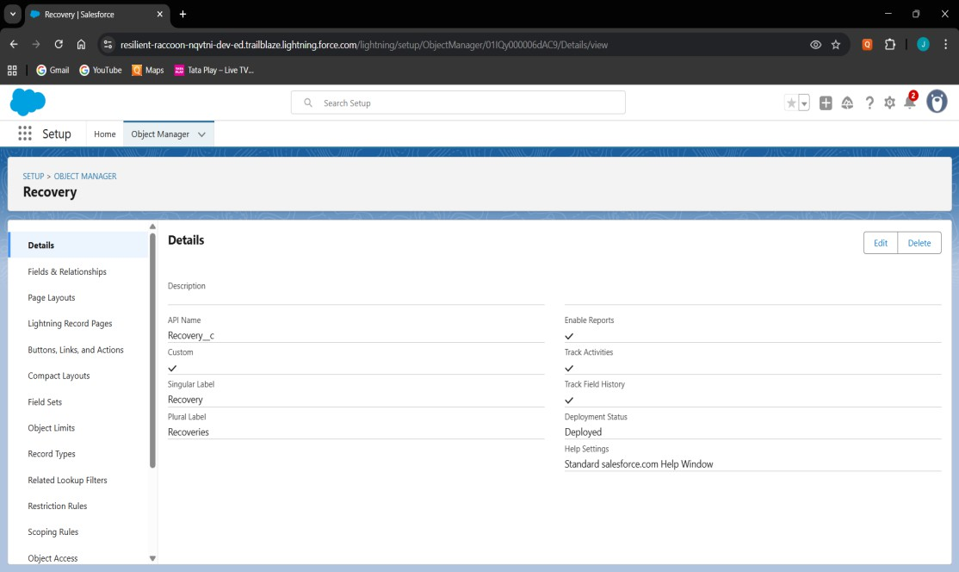

# Fields

* Loan: Loan Number (Auto Number), Principal Amount (Currency), Interest Rate (Percent), Term Months (Number), Start Date (Date), Status (Picklist), Customer (Lookup to Account/Contact).
* Payment: Payment Date (Date), Amount (Currency), Payment Method (Picklist: Cash/UPI/Transfer), Status (Picklist:

Paid/Overdue), Loan (Master-Detail).

* Recovery: Recovery Date (Date), Amount Recovered (Currency), Status (Picklist: Assigned/InProgress/Completed), Loan (Lookup), Assigned Agent (Lookup to User).
* Loan Agent Assignment (junction): Loan (Master-Detail), Assigned Agent (Lookup to User).

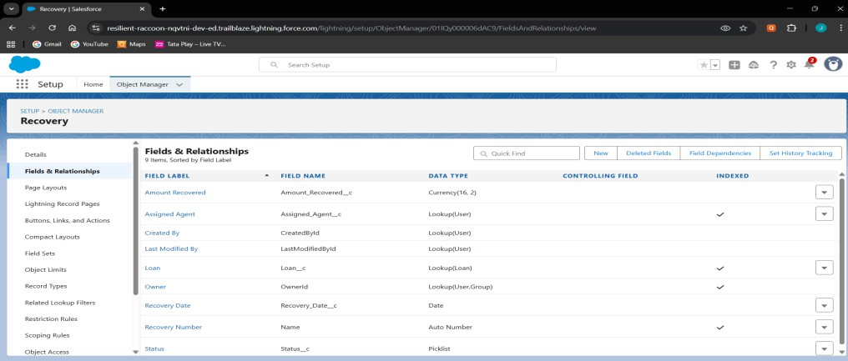

# Record Types

* Loan: Retail Loan & Business Loan.
* Configure Status picklist values per record type (e.g., Retail = Active/Closed, Business = Active/Defaulted).

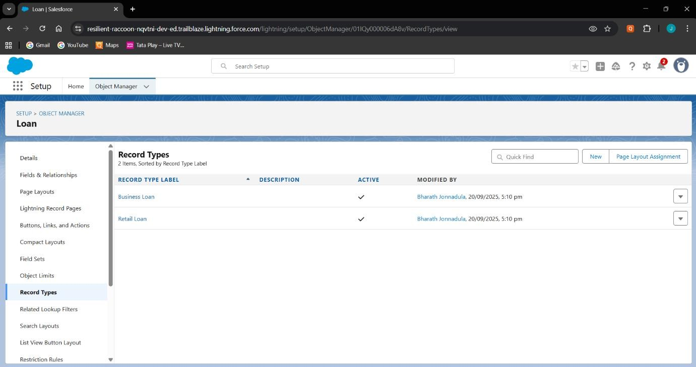

# Page Layouts

* Loan Layout: sections for Basic Info, Financials, Dates & Status. Related Lists = Payments, Recoveries, Loan Agent Assignments.
* Payment Layout: fields for Date, Amount, Method, Status.
* Recovery Layout: fields for Date, Amount Recovered, Status, Assigned Agent.

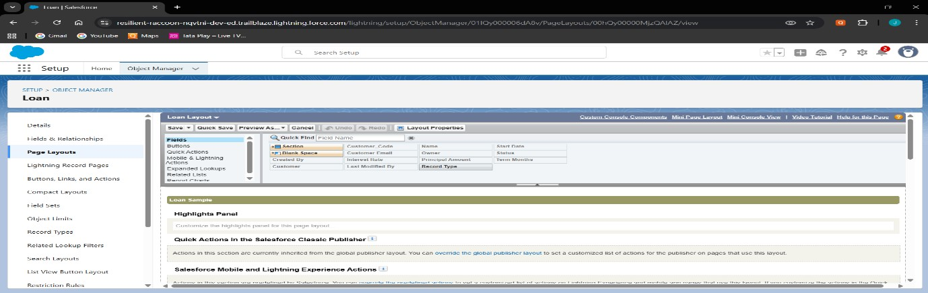

# Compact Layouts

* Loan Compact Layout: Loan Number, Principal Amount, Status, Customer.
* Payment Compact Layout: Payment Date, Amount, Status.
* Recovery Compact Layout: Recovery Date, Amount Recovered, Status.

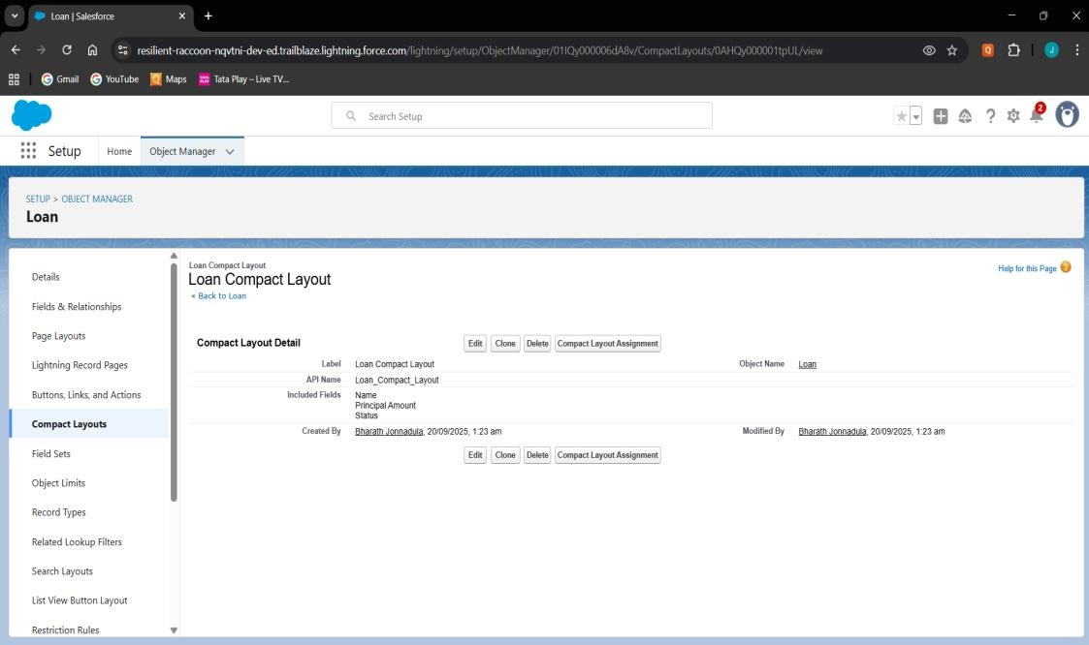

# Schema Builder

* Visualize Loan, Payment, Recovery, and Loan Agent Assignment objects.
* Confirm relationships: Loan–Payment (Master-Detail), Loan–

Recovery (Lookup), Loan–LoanAgentAssignment (Master-Detail), LoanAgentAssignment–User (Lookup).

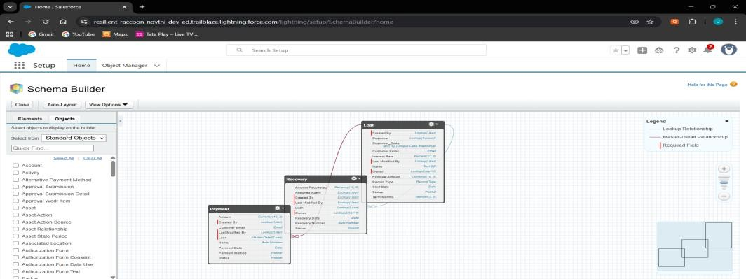

# Lookup vs Master-Detail vs Hierarchical

* Payment → Loan = Master-Detail (payments always tied to loans).
* Recovery → Loan = Lookup (independent audit records).
* Loan Agent Assignment → Loan = Master-Detail, → User = Lookup.
* Hierarchical not used (only for User object).

# Junction Objects

* Loan Agent Assignment to handle many-to-many between Loans and Agents.
* Enables multiple agents handling multiple loans.

# External Objects

* Connect to external payment system using Salesforce Connect.

# Phase 4: Process Automation (Admin) Validation Rules

* Ensure values are valid (Loan/Payment/Recovery > 0).
* Prevent negative amounts and invalid dates.

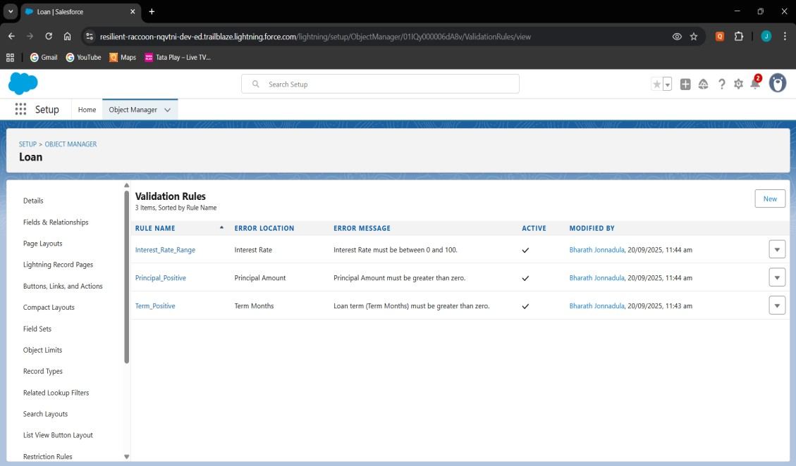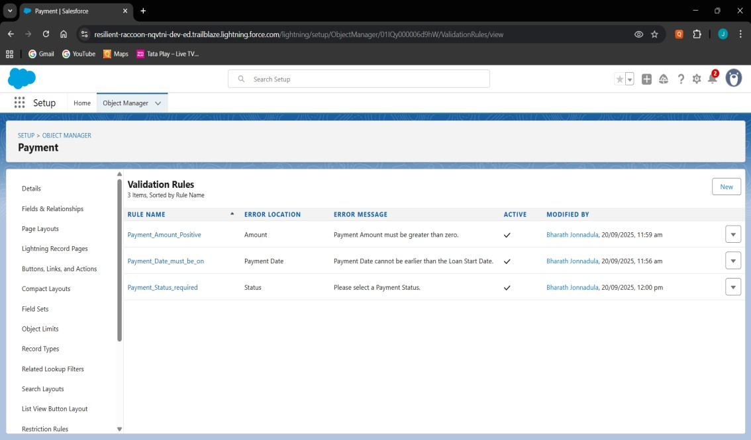

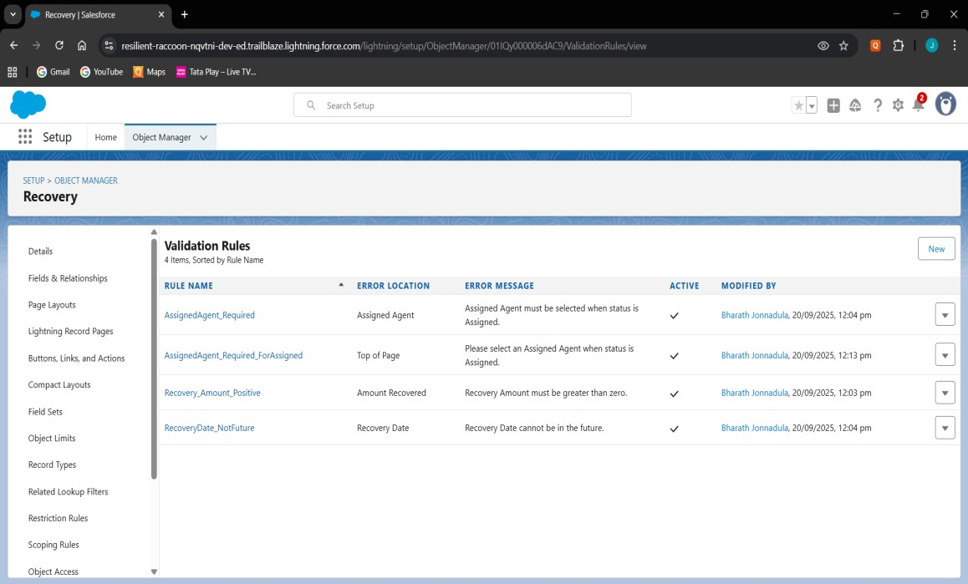

# Workflow Rules

* Rule: Pending_Payment_Reminder.
* 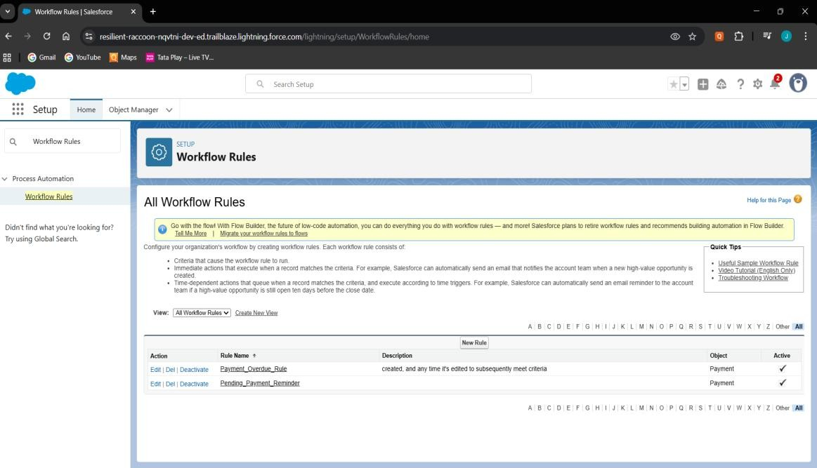Sends reminder email for pending payments.

# Process Builder

* Sends email reminders for due payments.
* Updates Loan status when all Payments are paid.
* Creates follow-up task for overdue payments.

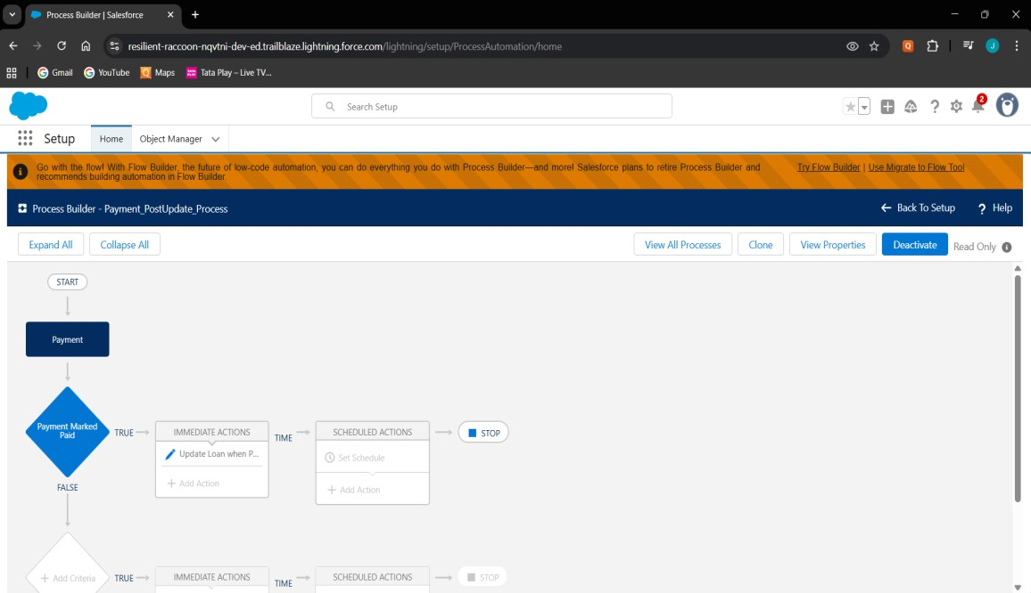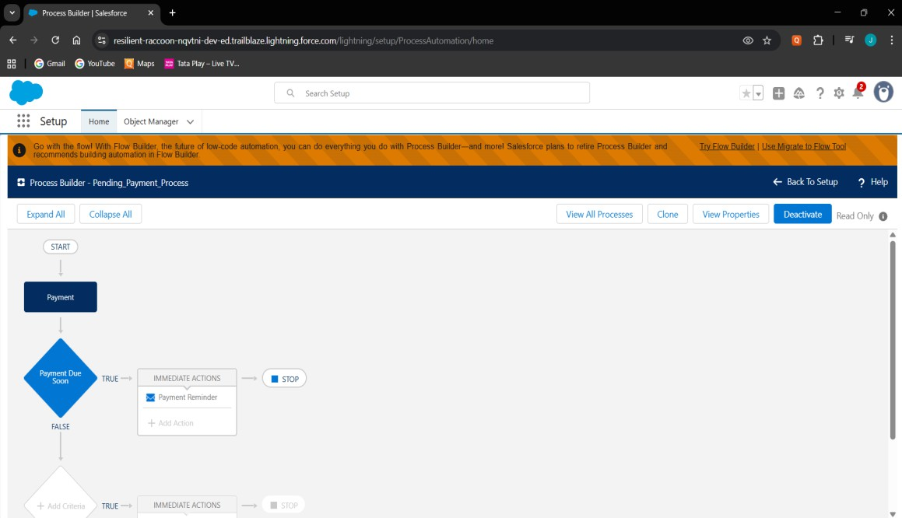

# Approval Process

* Loans > 5 Lakhs require Manager approval.
* Auto email + status update on approval/rejection.

# 

# Flow Builder

* Record-Triggered: Marks payments overdue automatically.
* Record-Triggered: Creates Recovery record when overdue.

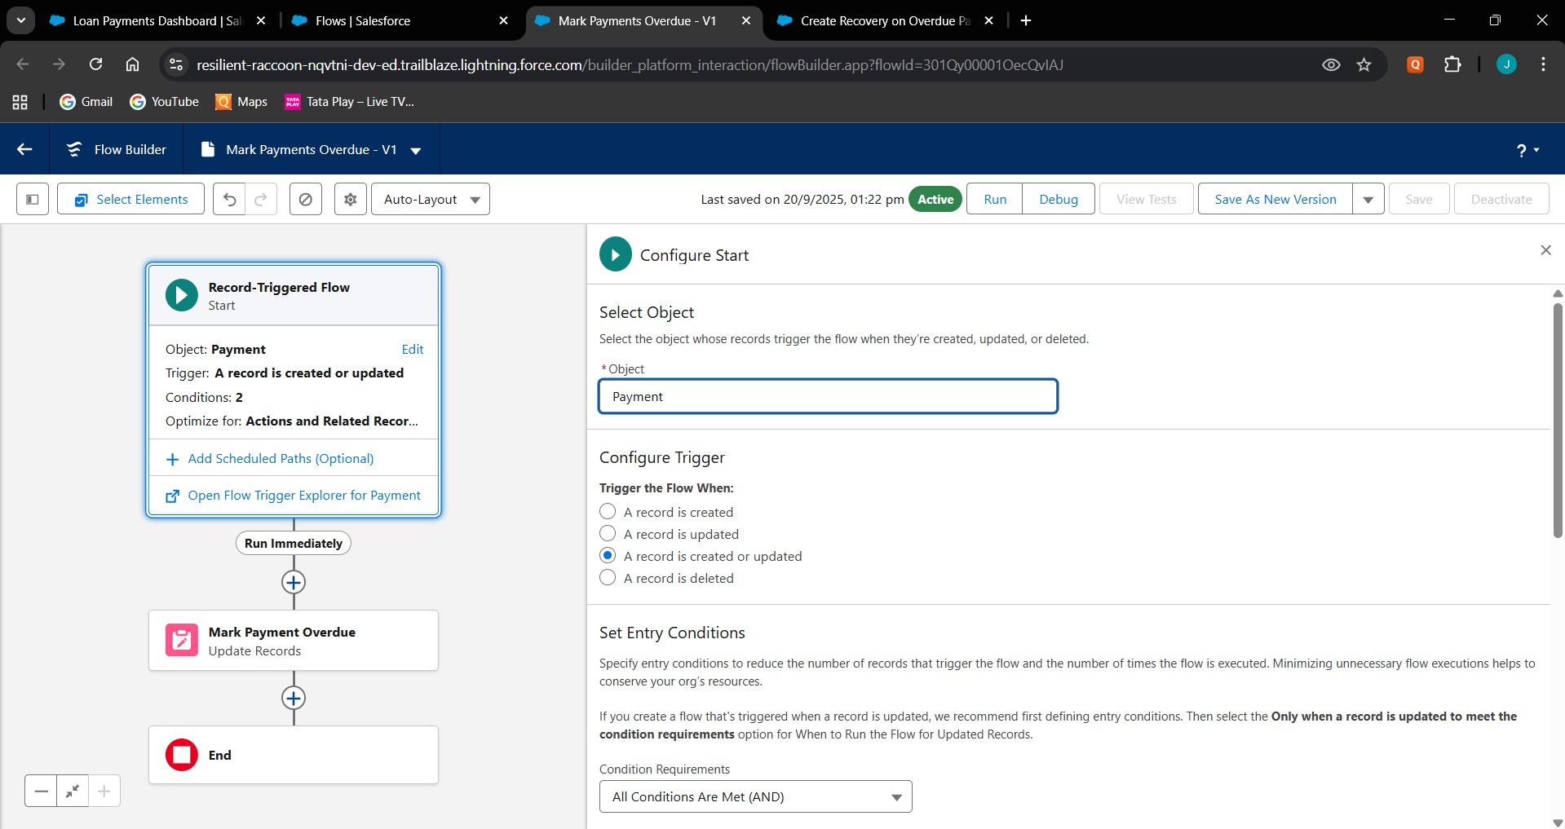**Mark Payments Overdue**

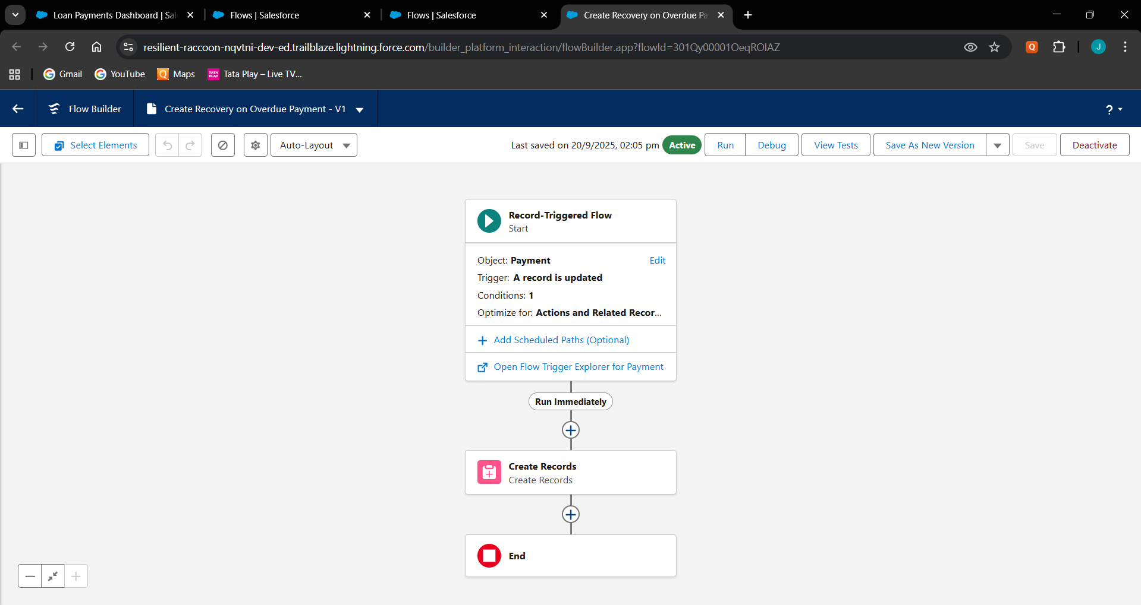**Create Recovery on Overdue**

# Email Alerts

* Payment_Reminder_Email → Customer.
* 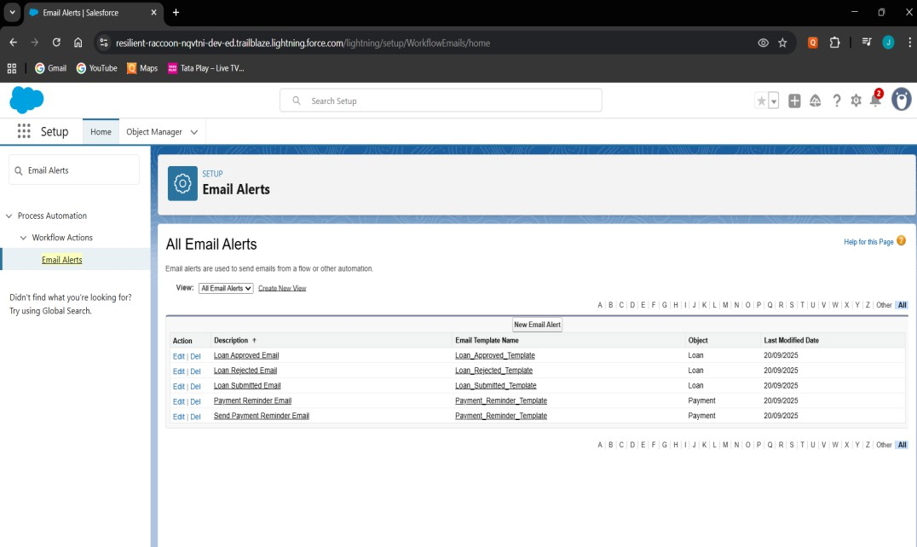Loan_Submitted, Approved, Rejected → Manager/Officer.

# Field Updates

* Auto-change Payment.Status to Overdue.
* 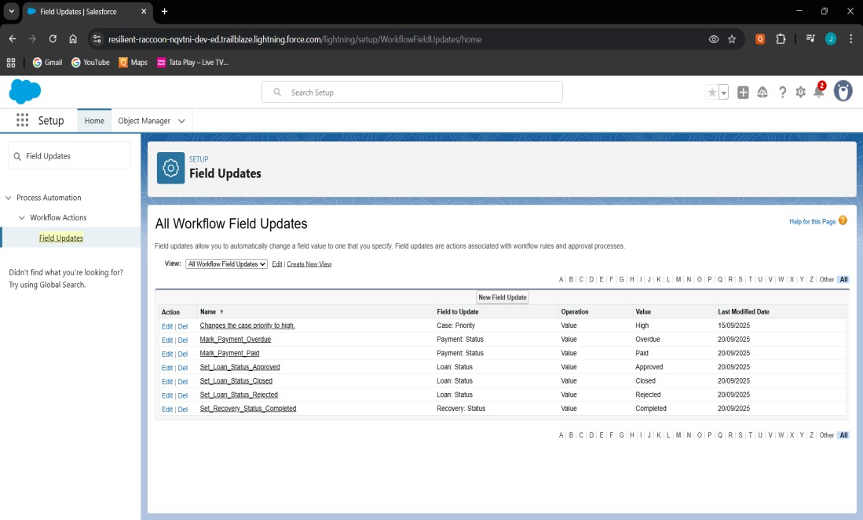Auto-close Loan when all Payments are Paid.

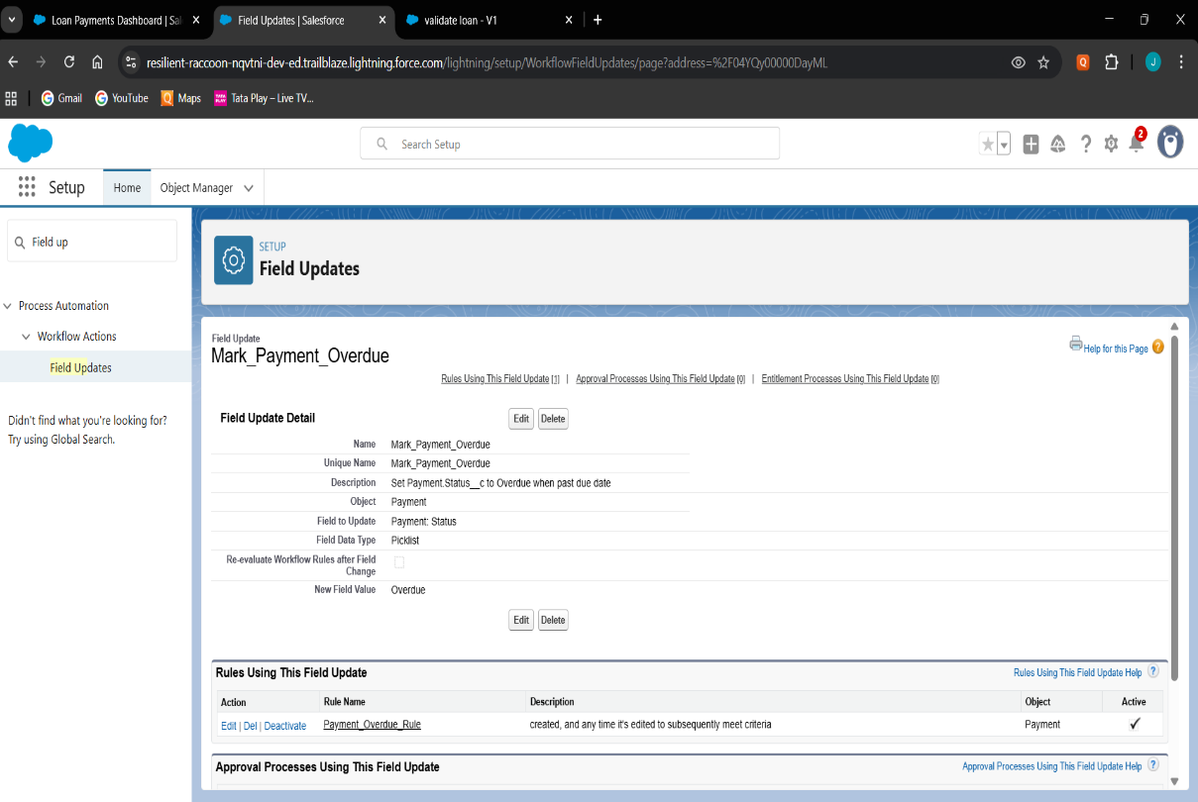

# Tasks

* Task created when Payment is Overdue.
* Assigned to Recovery Agent with high priority.

# Custom Notifications

* Sends in-app notification for Overdue Payments.

# Phase 5: Apex Programming (Developer) Classes & Objects

* Created Apex helper classes (LoanHandler, PaymentHandler, RecoveryHandler) to separate business logic from triggers.
* Used object-oriented approach for cleaner, reusable, and modular code.

**LoanHandler.cls**

public class LoanHandler {

    public static void beforeInsert(List<Loan__c> newLoans) {

        for (Loan__c loan : newLoans) {

            if (loan.Status__c == null) {

                loan.Status__c = 'Pending Approval';

            }

        }

    }

    public static void beforeUpdate(List<Loan__c> newLoans, Map<Id, Loan__c> oldMap) {

        for (Loan__c loan : newLoans) {

            Loan__c oldLoan = oldMap.get(loan.Id);

            if (loan.Principal_Amount__c != oldLoan.Principal_Amount__c) {

                loan.Status__c = 'Modified';

            }

        }

    }

    public static void afterInsert(List<Loan__c> newLoans) {

        System.debug('New Loans inserted: ' + newLoans);

    }

    public static void afterUpdate(List<Loan__c> newLoans, Map<Id, Loan__c> oldMap) {

        System.debug('Loans updated: ' + newLoans);

    }

    public static void afterDelete(List<Loan__c> oldLoans) {

        System.debug('Loans deleted: ' + oldLoans);

    }

}

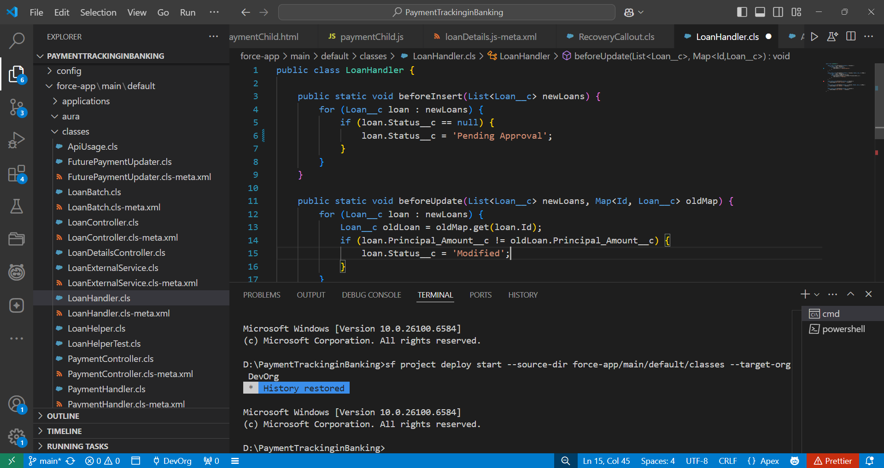

**PaymentHandler.cls**

public class PaymentHandler {

    public static void beforeInsert(List<Payment__c> newPayments) {

        for (Payment__c p : newPayments) {

            if (p.Status__c == null) p.Status__c = 'Pending';

        }

    }

    public static void beforeUpdate(List<Payment__c> newPayments, Map<Id, Payment__c> oldMap) {

        for (Payment__c p : newPayments) {

            Payment__c oldP = oldMap.get(p.Id);

            if (p.Amount__c != oldP.Amount__c) {

                p.Status__c = 'Revised';

            }

        }

    }

    public static void afterInsert(List<Payment__c> newPayments) {

        updateLoanStatus(newPayments);

    }

    public static void afterUpdate(List<Payment__c> newPayments, Map<Id, Payment__c> oldMap) {

        updateLoanStatus(newPayments);

    }

    public static void afterDelete(List<Payment__c> oldPayments) {

        updateLoanStatus(oldPayments);

    }

    private static void updateLoanStatus(List<Payment__c> payments) {

        Set<Id> loanIds = new Set<Id>();

        for (Payment__c p : payments) if (p.Loan__c != null) loanIds.add(p.Loan__c);

        if (loanIds.isEmpty()) return;

        Map<Id, Integer> totalPayments = new Map<Id, Integer>();

        for (AggregateResult ar : [

            SELECT Loan__c loanId, COUNT(Id) totalCount

            FROM Payment__c WHERE Loan__c IN :loanIds

            GROUP BY Loan__c

        ]) {

            totalPayments.put((Id) ar.get('loanId'), (Integer) ar.get('totalCount'));

        }

        Map<Id, Integer> paidPayments = new Map<Id, Integer>();

        for (AggregateResult ar : [

            SELECT Loan__c loanId, COUNT(Id) paidCount

            FROM Payment__c WHERE Loan__c IN :loanIds AND Status__c = 'Paid'

            GROUP BY Loan__c

        ]) {

            paidPayments.put((Id) ar.get('loanId'), (Integer) ar.get('paidCount'));

        }

        List<Loan__c> loansToUpdate = new List<Loan__c>();

        for (Id lid : loanIds) {

            Integer total = totalPayments.containsKey(lid) ? totalPayments.get(lid) : 0;

            Integer paid = paidPayments.containsKey(lid) ? paidPayments.get(lid) : 0;

            if (total > 0 && total == paid) {

                loansToUpdate.add(new Loan__c(Id = lid, Status__c = 'Closed'));

            } else {

                loansToUpdate.add(new Loan__c(Id = lid, Status__c = 'Active'));

            }

        }

        if (!loansToUpdate.isEmpty()) update loansToUpdate;

    }

}

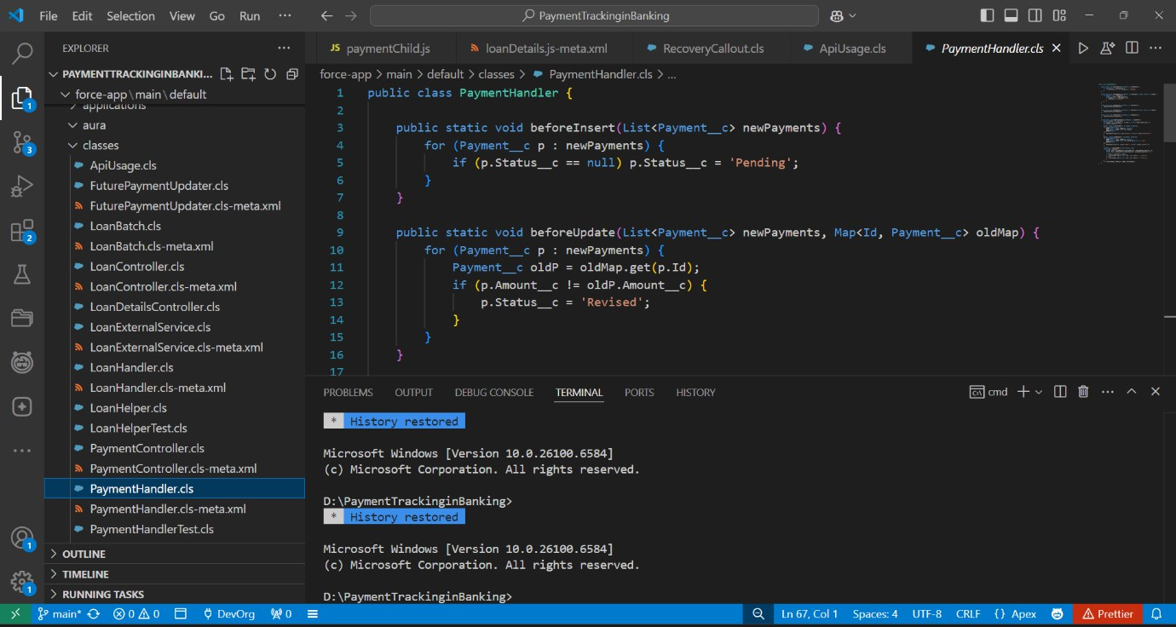

**RecoveryHandler.cls**

public class RecoveryHandler {

    public static void beforeInsert(List<Recovery__c> newRecoveries) {

        for (Recovery__c r : newRecoveries) {

            if (r.Status__c == null) r.Status__c = 'Assigned';

        }

    }

    public static void beforeUpdate(List<Recovery__c> newRecoveries, Map<Id, Recovery__c> oldMap) {

        for (Recovery__c r : newRecoveries) {

            Recovery__c oldR = oldMap.get(r.Id);

            if (r.Amount_Recovered__c != oldR.Amount_Recovered__c) {

                r.Status__c = 'Updated';

            }

        }

    }

    public static void afterInsert(List<Recovery__c> newRecoveries) {

        System.debug('New Recoveries: ' + newRecoveries);

    }

    public static void afterUpdate(List<Recovery__c> newRecoveries, Map<Id, Recovery__c> oldMap) {

        System.debug('Updated Recoveries: ' + newRecoveries);

    }

    public static void afterDelete(List<Recovery__c> oldRecoveries) {

        System.debug('Deleted Recoveries: ' + oldRecoveries);

    }

}

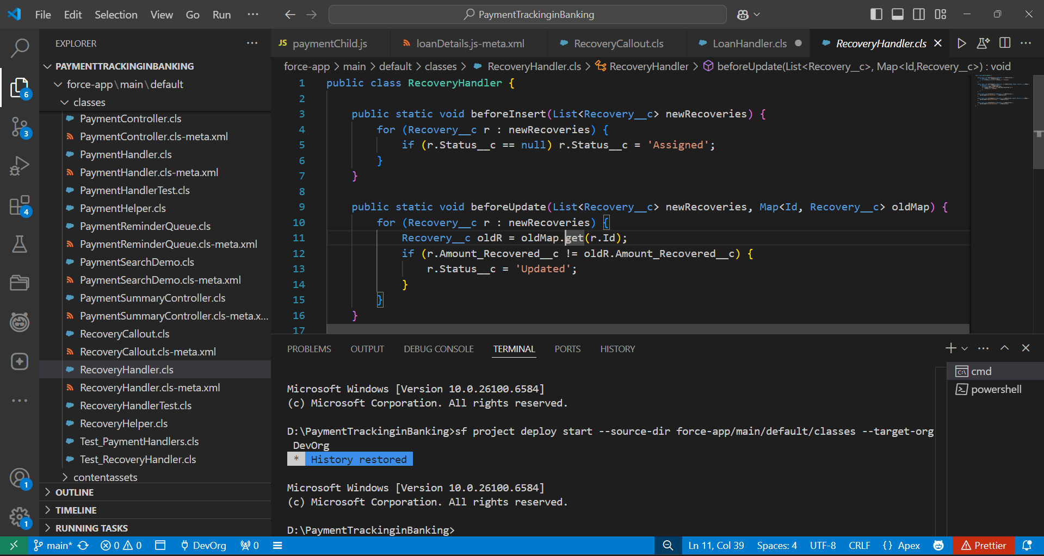

# Apex Triggers

* Implemented triggers for Loan, Payment, and Recovery to handle automation like updating statuses and roll-ups.

**LoanTrigger.trigger**

trigger LoanTrigger on Loan__c (

    before insert, before update,

    after insert, after update, after delete

) {

    if (Trigger.isBefore) {

        if (Trigger.isInsert) LoanHandler.beforeInsert(Trigger.new);

        if (Trigger.isUpdate) LoanHandler.beforeUpdate(Trigger.new, Trigger.oldMap);

    }

    if (Trigger.isAfter) {

        if (Trigger.isInsert) LoanHandler.afterInsert(Trigger.new);

        if (Trigger.isUpdate) LoanHandler.afterUpdate(Trigger.new, Trigger.oldMap);

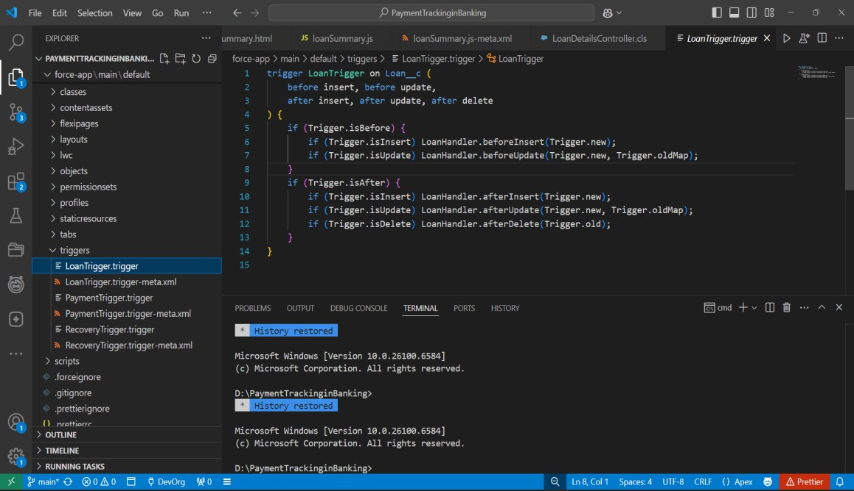        if (Trigger.isDelete) LoanHandler.afterDelete(Trigger.old);}}}

**PaymentTrigger.trigger**

trigger PaymentTrigger on Payment__c (

    before insert, before update,

    after insert, after update, after delete

) {

    if (Trigger.isBefore) {

        if (Trigger.isInsert) PaymentHandler.beforeInsert(Trigger.new);

        if (Trigger.isUpdate) PaymentHandler.beforeUpdate(Trigger.new, Trigger.oldMap);

    }

    if (Trigger.isAfter) {

        if (Trigger.isInsert) PaymentHandler.afterInsert(Trigger.new);

        if (Trigger.isUpdate) PaymentHandler.afterUpdate(Trigger.new, Trigger.oldMap);

        if (Trigger.isDelete) PaymentHandler.afterDelete(Trigger.old);

    }

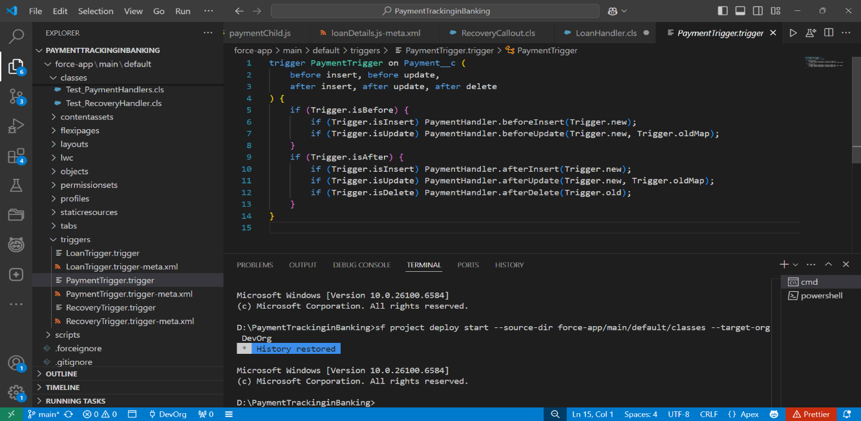}

**RecoveryTrigger.trigger**

trigger RecoveryTrigger on Recovery__c (

    before insert, before update,

    after insert, after update, after delete

) {

    if (Trigger.isBefore) {

        if (Trigger.isInsert) RecoveryHandler.beforeInsert(Trigger.new);

        if (Trigger.isUpdate) RecoveryHandler.beforeUpdate(Trigger.new, Trigger.oldMap);

    }

    if (Trigger.isAfter) {

        if (Trigger.isInsert) RecoveryHandler.afterInsert(Trigger.new);

        if (Trigger.isUpdate) RecoveryHandler.afterUpdate(Trigger.new, Trigger.oldMap);

        if (Trigger.isDelete) RecoveryHandler.afterDelete(Trigger.old);

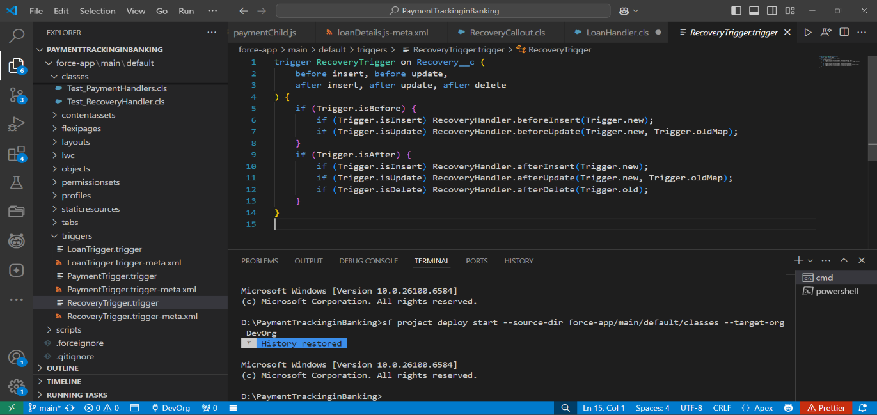    }}

# Trigger Design Pattern

* Applied Trigger Handler Pattern to keep trigger code clean and delegate logic to handler classes.
* 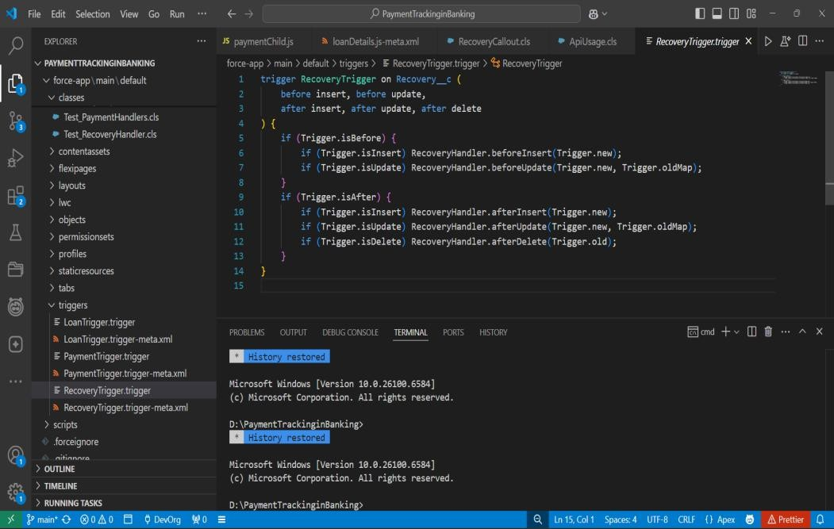Ensured only one trigger per object with proper event handling.

# SOQL & SOSL

* Used SOQL in classes to query Loans, Payments, and Recoveries.
* Implemented simple search functionality to fetch customer records.

**LoanDetailsController.cls**

public with sharing class LoanController {

    @AuraEnabled(cacheable=true)

    public static Loan__c getLoan(String loanId) {

      return [SELECT  Name, Principal_Amount__c FROM Loan__c WHERE Id = :loanId LIMIT 1];

    }

@AuraEnabled

    public static Boolean markLoanClosed(String loanId) {

      try {

        Loan__c L = [SELECT Id, Status__c FROM Loan__c WHERE Id = :loanId LIMIT 1];

        L.Status__c = 'Closed';

        update L;

        return true;

      } catch (Exception e) {

        throw new AuraHandledException('Cannot close loan: ' + e.getMessage());

      }

    }

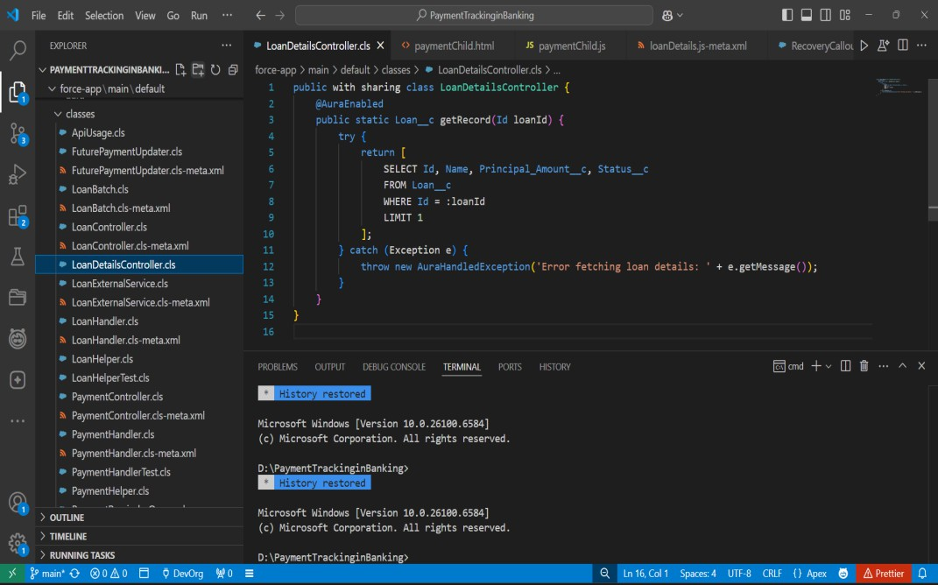  }

**PaymentsController.cls**

public class PaymentController {

    @AuraEnabled(cacheable=true)

    public static List<Payment__c> getPayments(Id loanId) {

        if (loanId == null) return new List<Payment__c>();

        return [

            SELECT Name, Amount__c, Status__c, Payment_Date__c

            FROM Payment__c

            WHERE Loan__c = :loanId

            ORDER BY Payment_Date__c DESC

];

}

}

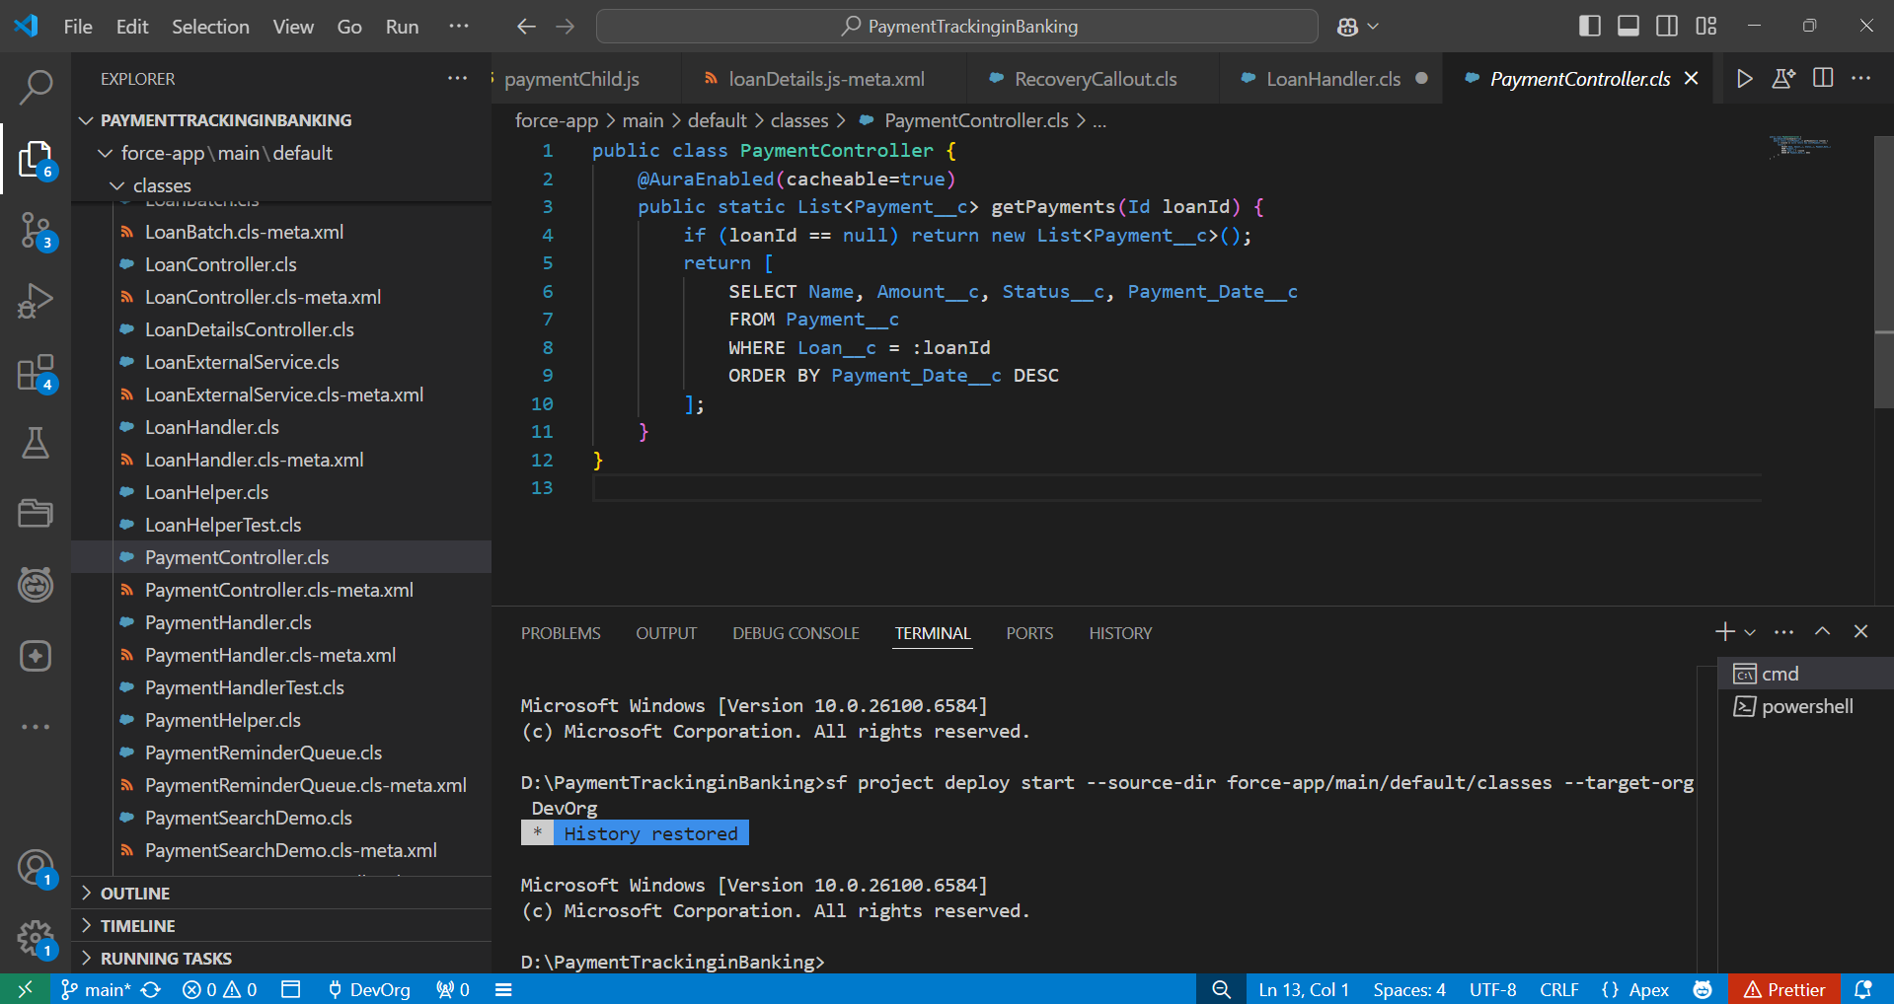

# Collections: List, Set, Map

* Applied Lists to hold multiple Payments for bulk processing.
* Used Maps for Loan → Payments mapping to handle roll-ups efficiently.

**PaymentRemainderQueue.cls**

public class PaymentReminderQueue implements Queueable {

    public void execute(QueueableContext context) {

        List<Payment__c> duePayments = [

            SELECT Id, Status__c FROM Payment__c WHERE Status__c = 'Pending'

        ];

        for (Payment__c p : duePayments) {

            p.Status__c = 'Reminder Sent';

        }

        update duePayments;

        System.debug(' Queue Job executed for reminders.');

    }

}

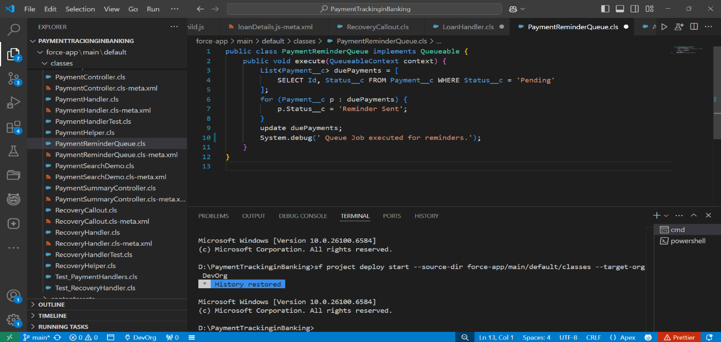

# Control Statements

* Implemented IF conditions for validation.

**RecoveryHandler.cls**

public class RecoveryHandler {

    public static void beforeInsert(List<Recovery__c> newRecoveries) {

        for (Recovery__c r : newRecoveries) {

            if (r.Status__c == null) r.Status__c = 'Assigned';

        }

    }

    public static void beforeUpdate(List<Recovery__c> newRecoveries, Map<Id, Recovery__c> oldMap) {

        for (Recovery__c r : newRecoveries) {

            Recovery__c oldR = oldMap.get(r.Id);

            if (r.Amount_Recovered__c != oldR.Amount_Recovered__c) {

                r.Status__c = 'Updated';

            }

        }

    }

    public static void afterInsert(List<Recovery__c> newRecoveries) {

        System.debug('New Recoveries: ' + newRecoveries);

    }

public static void afterUpdate(List<Recovery__c> newRecoveries, Map<Id, Recovery__c> oldMap) {

        System.debug('Updated Recoveries: ' + newRecoveries);

    }

    public static void afterDelete(List<Recovery__c> oldRecoveries) {

        System.debug('Deleted Recoveries: ' + oldRecoveries);

    }

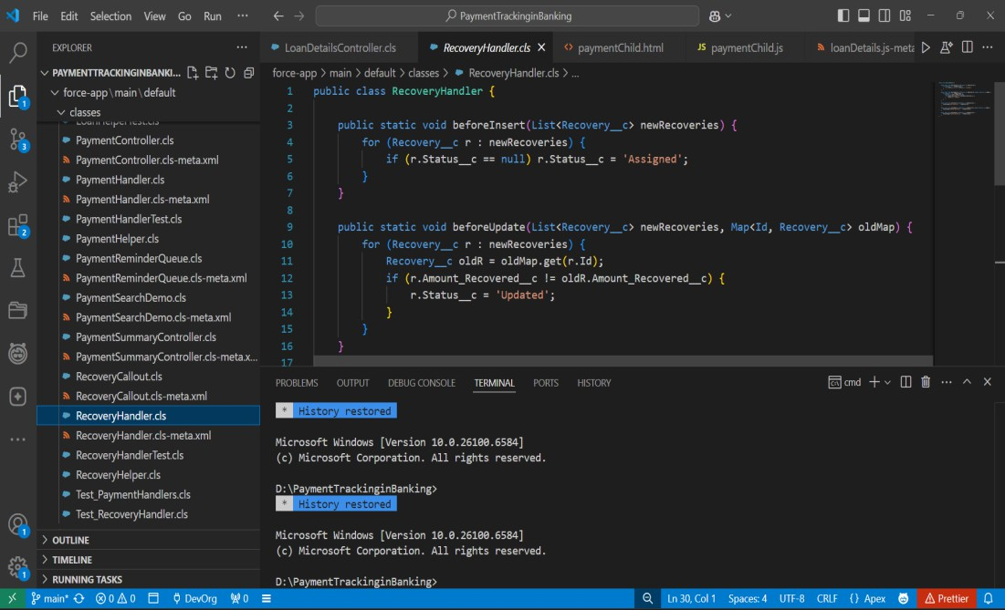}

# Batch Apex

* Created simple batch class for recalculating loan balances.
* Enabled processing of large datasets asynchronously.

**LoanBatch.cls**

global class LoanBatch implements Database.Batchable<sObject> {

    global Database.QueryLocator start(Database.BatchableContext bc) {

        return Database.getQueryLocator('SELECT Id, Status__c FROM Loan__c WHERE Status__c = \'Active\'');

    }

    global void execute(Database.BatchableContext bc, List<Loan__c> scope) {

        for (Loan__c l : scope) {

            l.Status__c = 'Closed';

        }

        update scope;

    }

    global void finish(Database.BatchableContext bc) {

        System.debug(' Loan Batch finished updating loans.');

    }

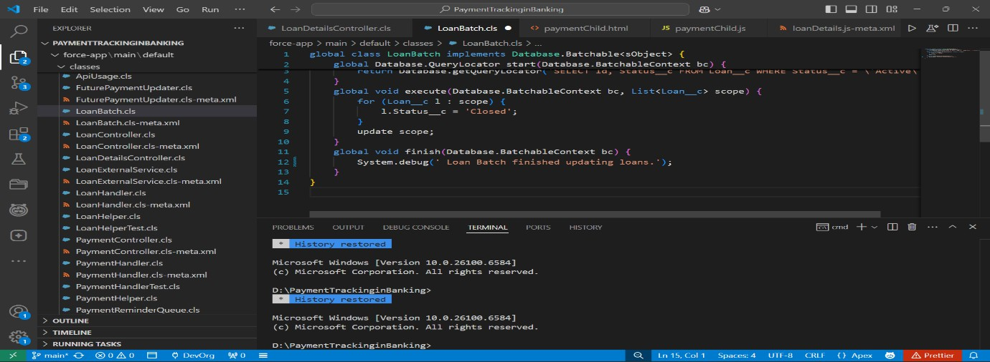}

# Queueable Apex

* Used Queueable Apex for lightweight async operations like notifications.
* 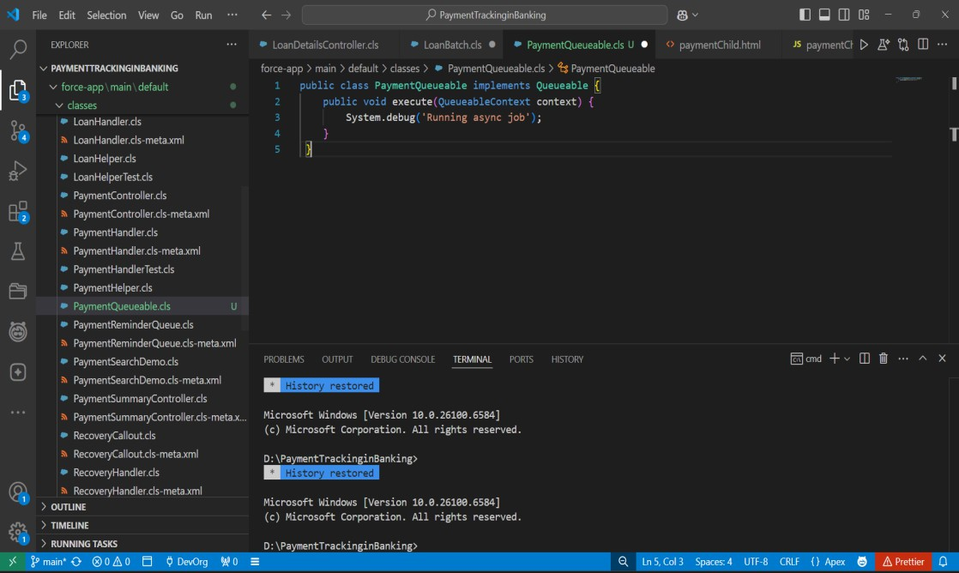Provides better chaining support compared to future methods.

# Scheduled Apex

* Built a scheduler to run daily overdue payment checks.
* Automated reminders and recovery creation without manual intervention.

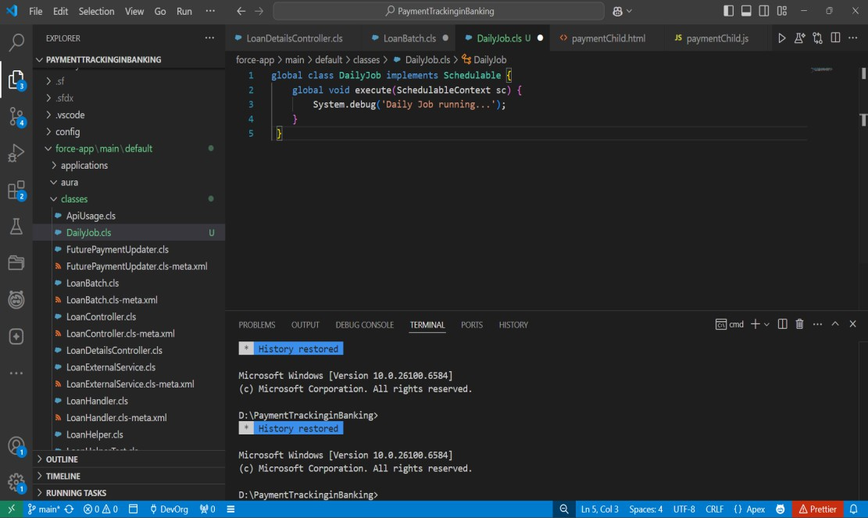

# Future Methods

* Implemented future call for sending async email notifications.

# Exception Handling

* Created a centralized ErrorHandler class to log and handle exceptions.
* Ensured smooth error reporting without stopping automation.

**LoanHelper.cls**

public class LoanHelper {

    public static void beforeInsert(List<Loan__c> newLoans) {

        try {

            for (Loan__c loan : newLoans) {

                if (loan.Amount__c <= 0) {

                    throw new PaymentTrackingException('Loan Amount must be greater than 0.');

                }

            }

        } catch (Exception ex) {

            String msg = ErrorHandler.logError(ex, 'LoanHelper.beforeInsert');

            ErrorHandler.notifyAdmin('Loan Insert Error', msg);

            throw ex;

        }

    }

}

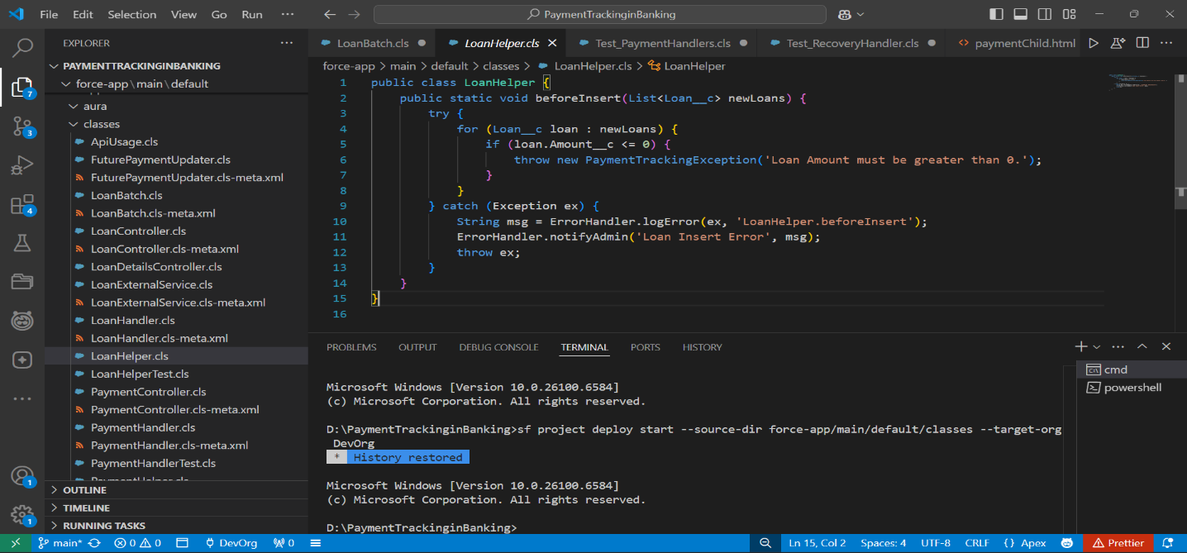

**PaymentHelper.cls**

public class PaymentHandler {

    public static void beforeInsert(List<Payment__c> newPayments) {

        try {

            for (Payment__c pay : newPayments) {

                if (pay.Payment_Date__c == null) {

                    throw new PaymentTrackingException('Payment Date is required.');

                }

            }

        } catch (Exception ex) {

            String msg = ErrorHandler.logError(ex, 'PaymentHandler.beforeInsert');

            ErrorHandler.notifyAdmin('Payment Insert Error', msg);

            throw ex;

        }

    }

    public static void afterUpdate(List<Payment__c> updatedPayments) {

        try {

for (Payment__c pay : updatedPayments) {

                if (pay.Status__c == 'Overdue') {

                    System.debug('Payment ' + pay.Id + ' is overdue. Creating recovery...');

                }

            }

        } catch (Exception ex) {

            String msg = ErrorHandler.logError(ex, 'PaymentHandler.afterUpdate');

            ErrorHandler.notifyAdmin('Payment Update Error', msg);

        }

    }

}

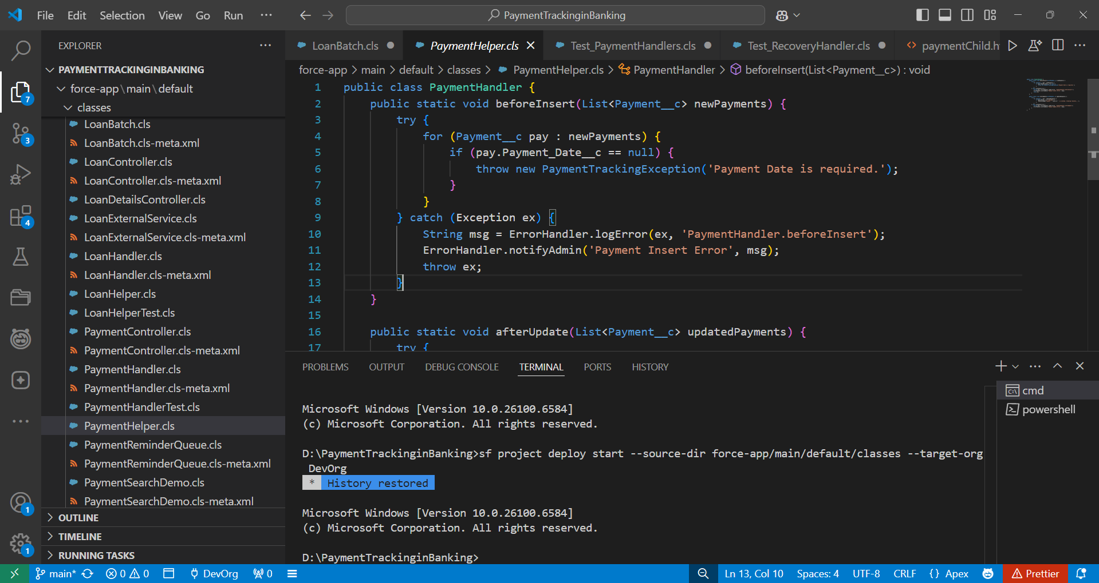

# Test Classes

* Wrote test classes for each handler & trigger to validate functionality.

**LoanHelperTest.cls**

@isTest

public class LoanHelperTest {

    @isTest

    static void testLoanBeforeInsert() {

        Loan__c loan = new Loan__c(

            Principal_Amount__c = 50000,

            Term_Months__c = 12,

            Interest_Rate__c = 10

        );

        Test.startTest();

        insert loan;

        Test.stopTest();

        System.assertNotEquals(null, loan.Id);

    }

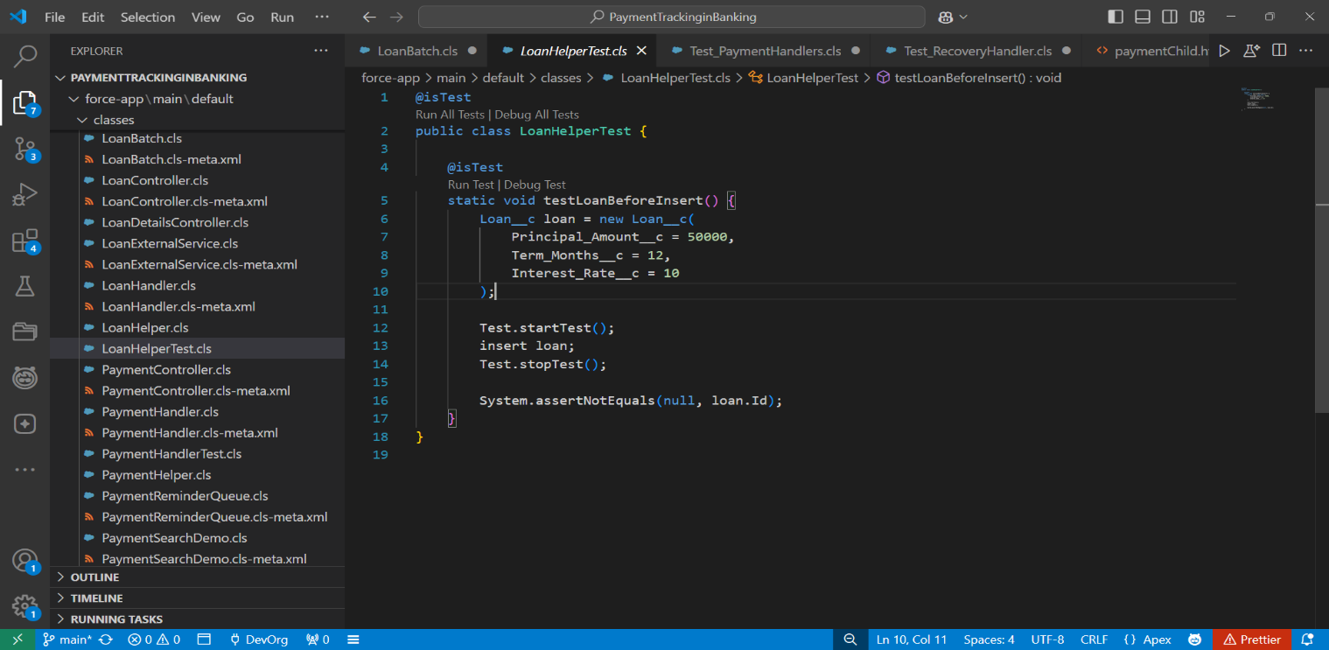}

**Test_PaymentHandlers.cls**

@IsTest

private class Test_PaymentHandlers {

    @IsTest static void testPaymentInsertAndLoanClose() {

        Loan__c loan = new Loan__c(Name='TestLoan', Principal_Amount__c = 1000.00, Status__c='Active');

        insert loan;

        Payment__c p1 = new Payment__c(Name='P1', Loan__c = loan.Id, Payment_Date__c = Date.today().addDays(1), Amount__c = 500, Status__c='Pending');

        Payment__c p2 = new Payment__c(Name='P2', Loan__c = loan.Id, Payment_Date__c = Date.today().addDays(2), Amount__c = 500, Status__c='Pending');

        insert new List<Payment__c>{p1,p2};

        p1.Status__c = 'Paid';

        p2.Status__c = 'Paid';

        update new List<Payment__c>{p1,p2};

        Loan__c refreshed = [SELECT Id, Status__c FROM Loan__c WHERE Id = :loan.Id];

        System.assertEquals('Closed', refreshed.Status__c);

    }

    @IsTest static void testPaymentOverdueBeforeInsert() {

        Loan__c loan = new Loan__c(Name='L2', Principal_Amount__c=1000.00);

        insert loan;

        Payment__c p = new Payment__c(Name='past', Loan__c = loan.Id, Payment_Date__c = Date.today().addDays(-2), Amount__c = 100, Status__c=null);

        insert p;

        Payment__c got = [SELECT Id, Status__c FROM Payment__c WHERE Id = :p.Id];

        System.assertEquals('Overdue', got.Status__c);

    }

}

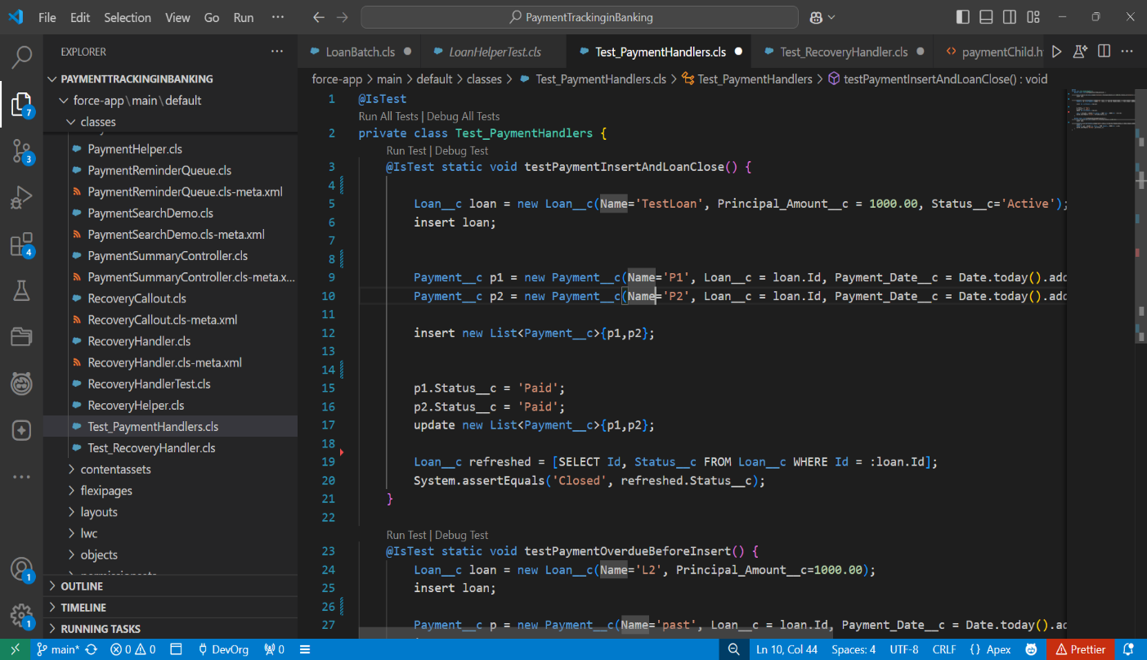

**Test_RecoveryHandlers.cls**

@IsTest

private class Test_RecoveryHandler {

    @IsTest static void testRecoveryFailsOnNegativeAmount() {

        Recovery__c r = new Recovery__c(Name='R1', Amount_Recovered__c = -10);

        try {

            insert r;

            System.assert(false, 'Expected DML exception for negative amount');

        } catch (DmlException ex) {

            System.assert(ex.getMessage().contains('Amount Recovered must be greater than 0.'));

        }

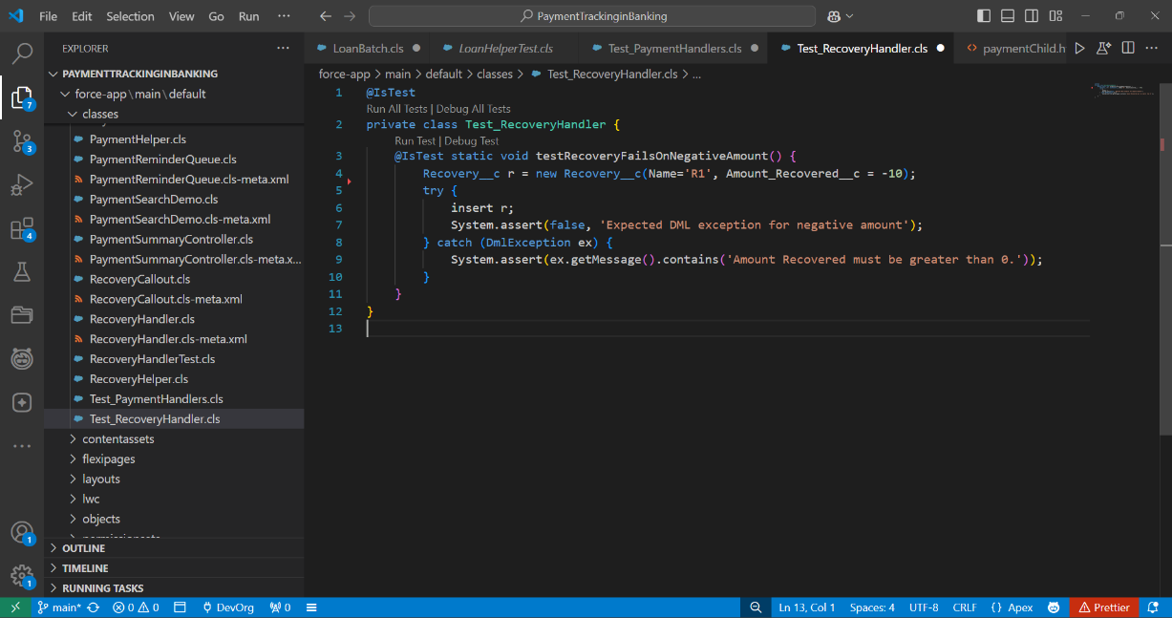    }

}

# Asynchronous Processing

* Combined Batch, Queueable, Scheduled, and Future methods for async operations.

# Phase 6: User Interface Development Lightning App Builder

* Created a custom Loan_Record_Page, Payment_Home_Page, Payment_Record_Page, Recovery_record_Page

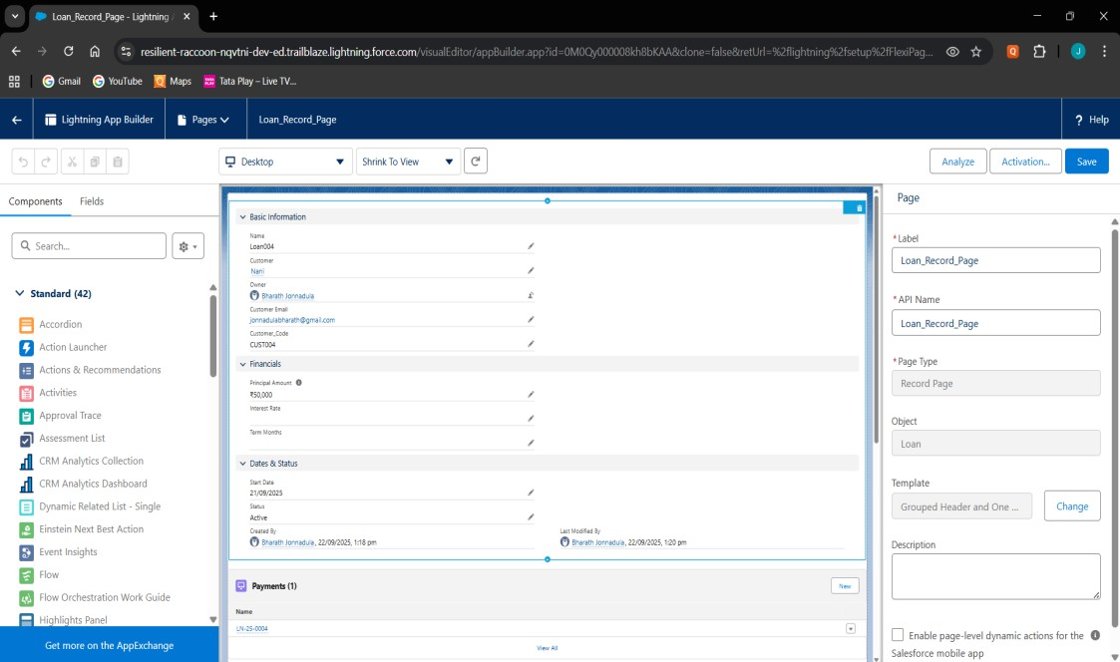

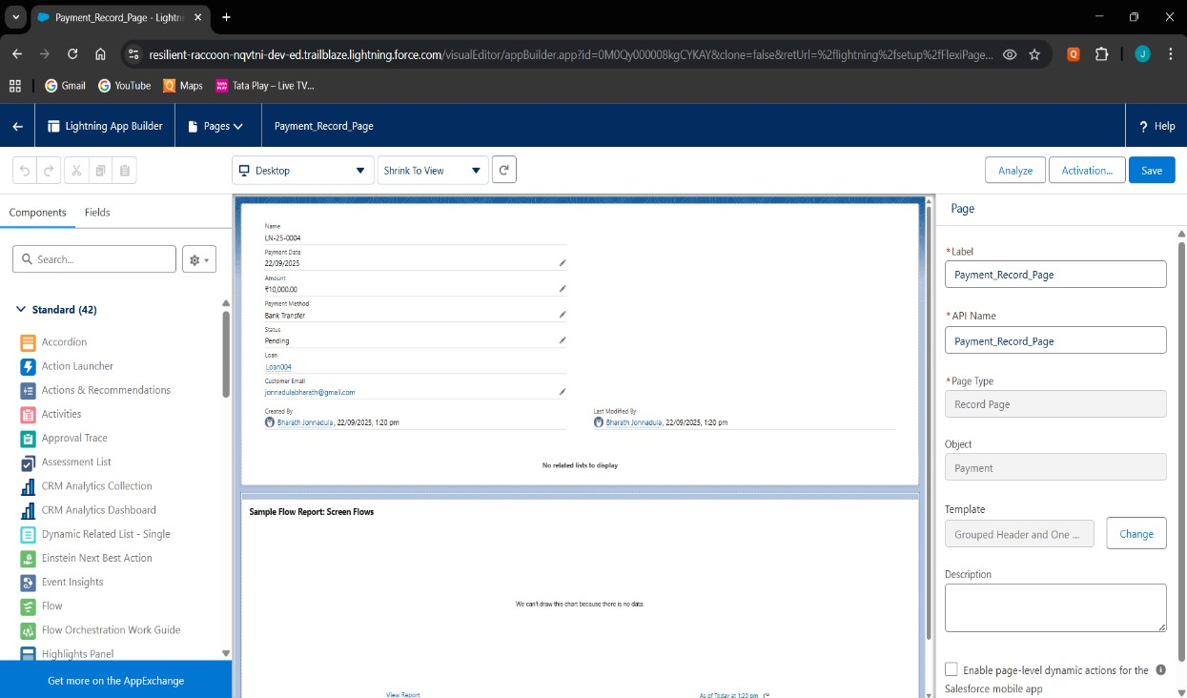

# Record Pages

* Built custom Record Pages for Loan and Payment objects using Lightning App Builder.

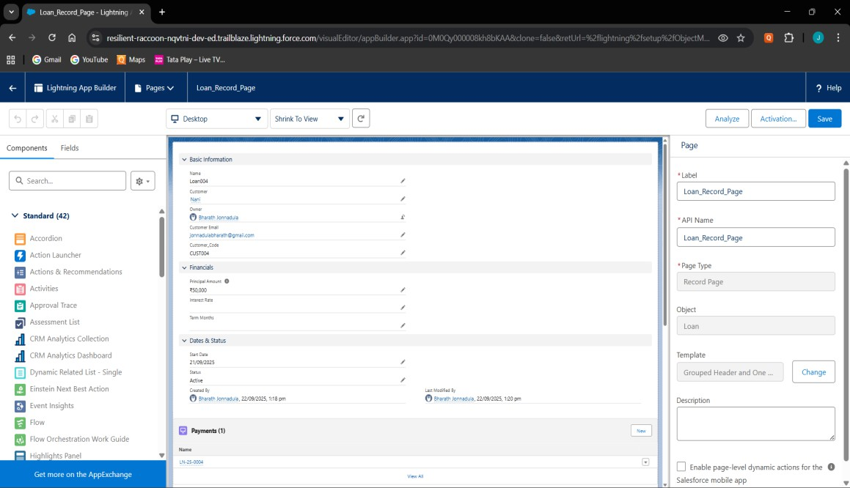

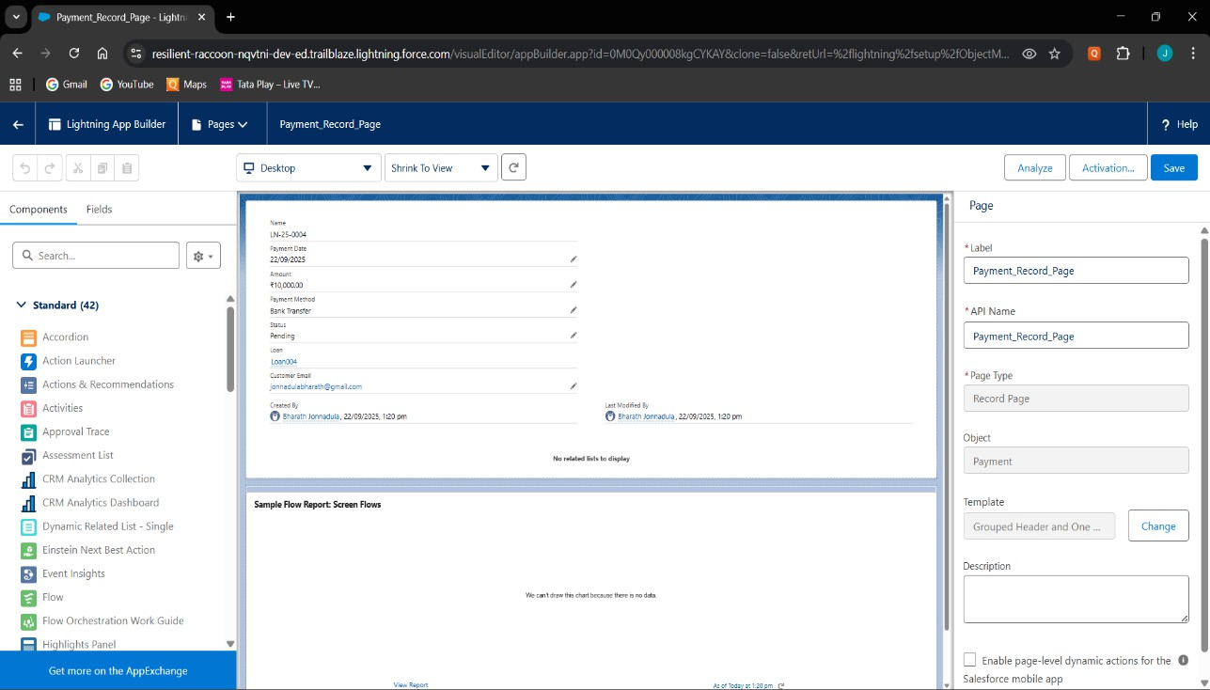

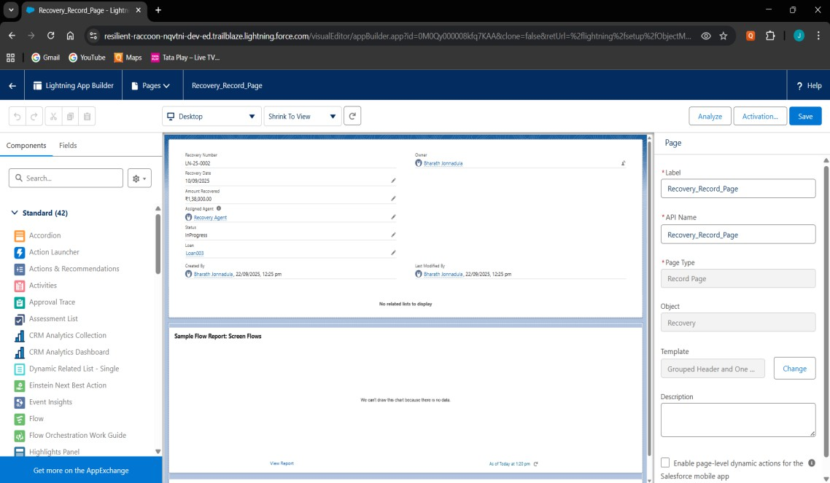

# Tabs

* Added custom tabs for Loan, Payment, and Recovery objects.

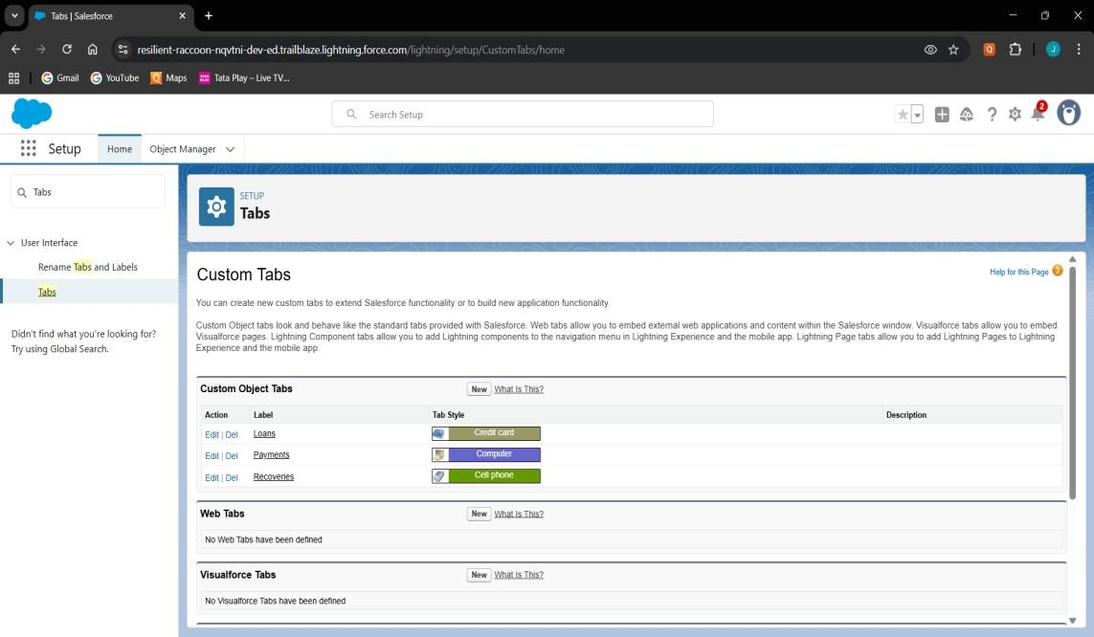

# Home Page Layouts

* Customized the Home Page with components like Recent Loans, Pending Payments

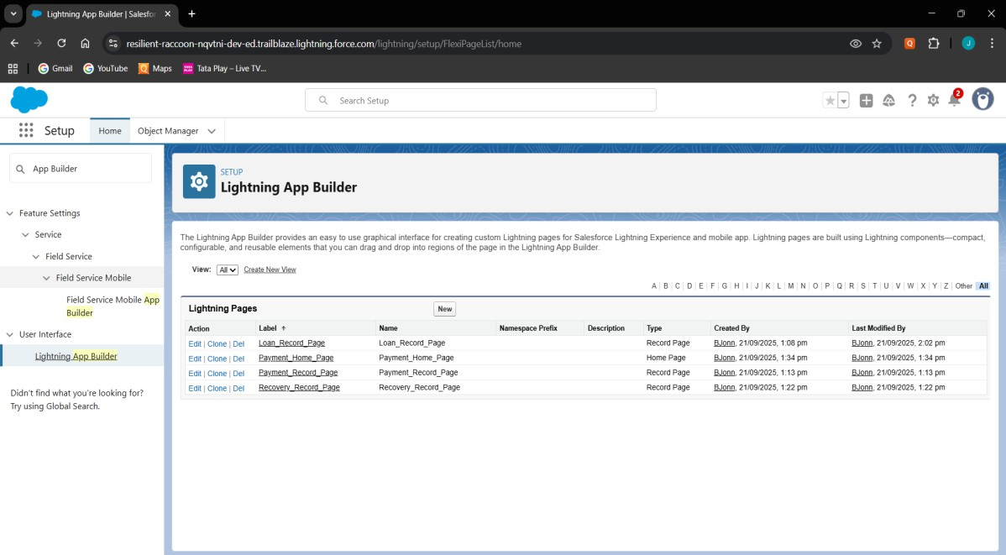

# Utility Bar

* 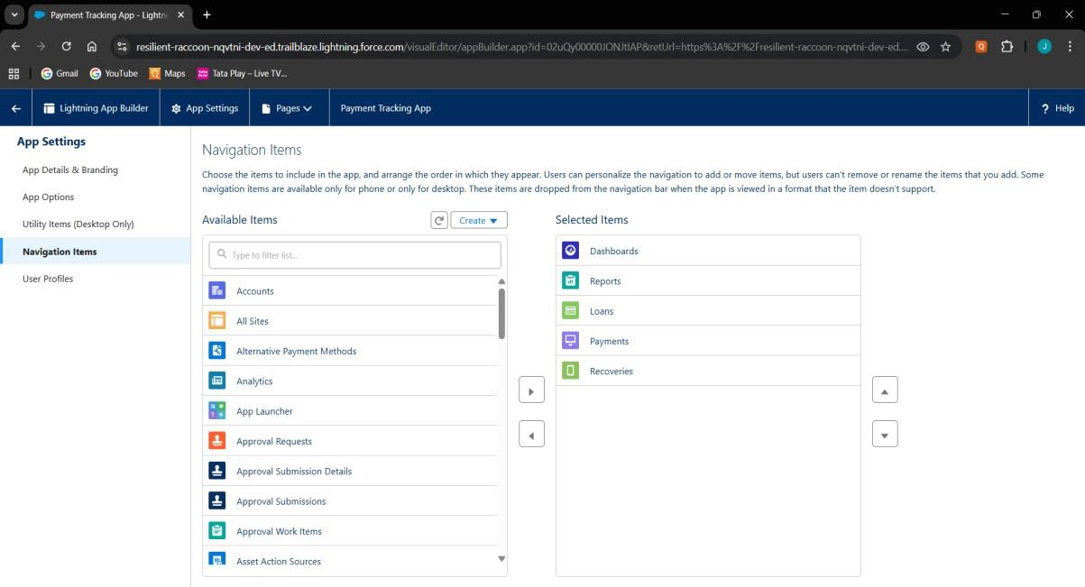Switch between loan & payment records.

# LWC (Lightning Web Components)

* Built LWC components (loanSummary, loanDetails, paymentChild).

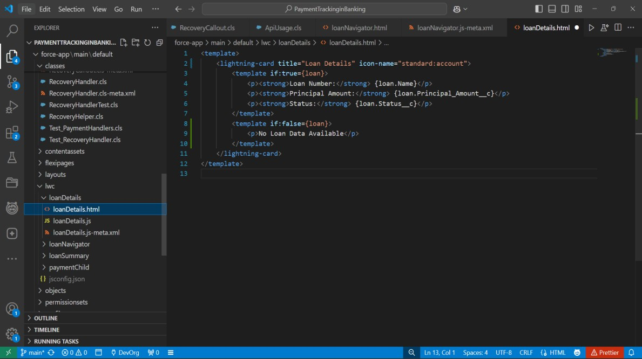

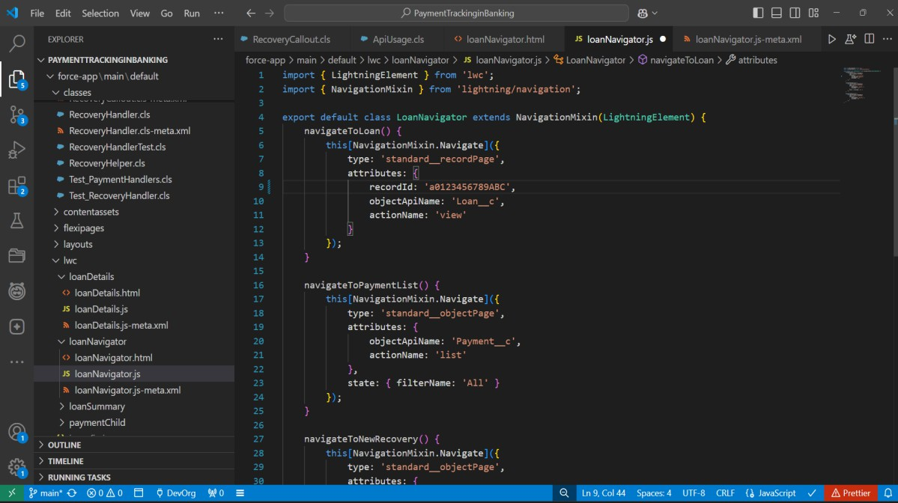

# Wire Adapters

* Used @wire(getRecord) to fetch Loan fields directly in LWC.

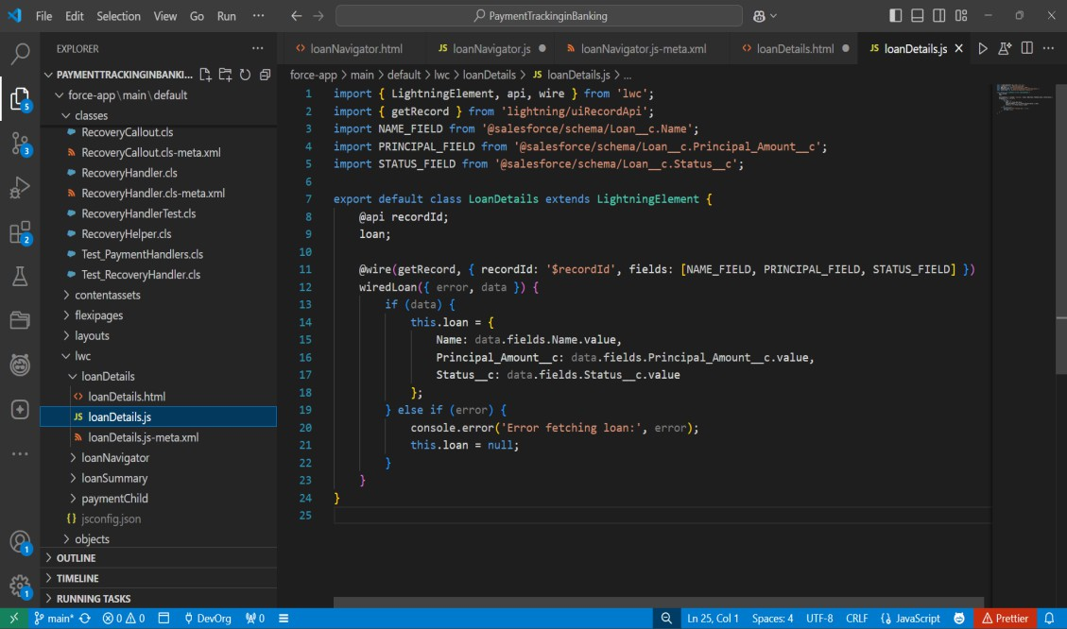

# Navigation Service

* Implemented NavigationMixin to let users navigate from Payment

→ Loan detail page.

* Improves user experience with one-click record redirection.

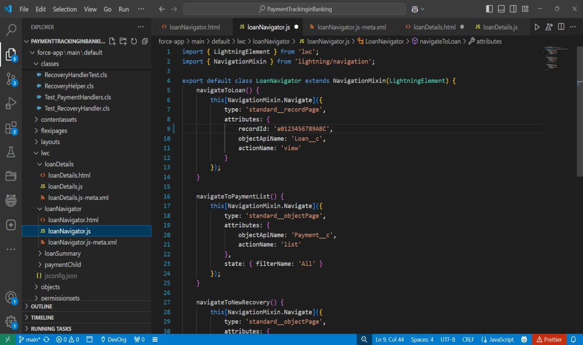

# Phase 7: Integration & External Access Named Credentials

* Used to securely store API endpoints + authentication details for external systems.

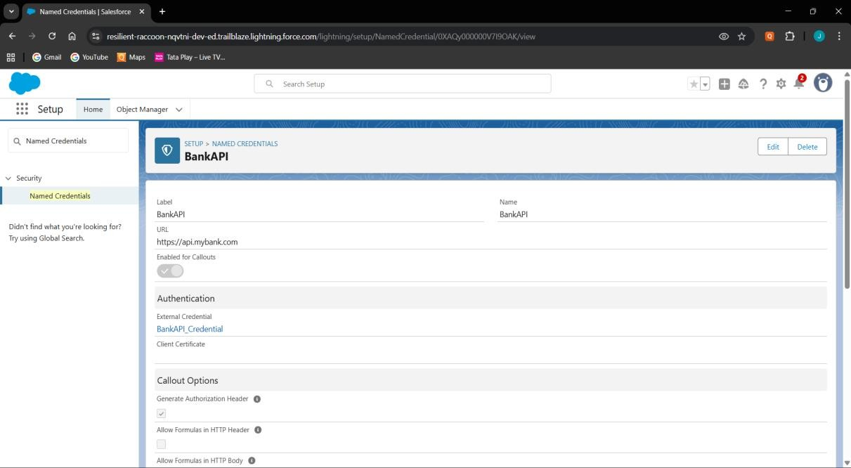

# External Services

* Lets Salesforce call external APIs using schema (Swagger/OpenAPI).

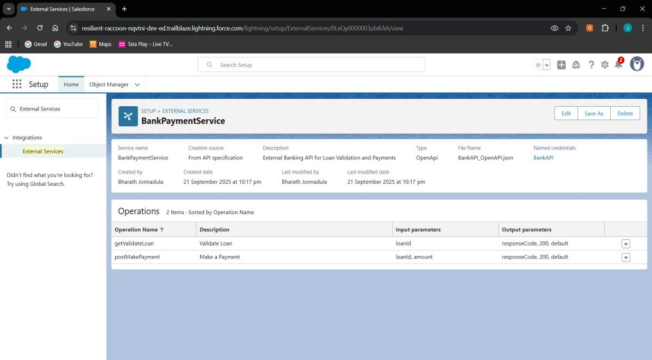

# Web Services (REST/SOAP)

* Allow external system to fetch Loan details.

**LoanExternalService.cls**

public with sharing class LoanExternalService {

    public static String getLoanValidation(String loanId) {

        HttpRequest req = new HttpRequest();

        req.setEndpoint('callout:BankAPI/validateLoan?loanId=' + loanId);

        req.setMethod('GET');

        Http http = new Http();

HttpResponse res = http.send(req);

if (res.getStatusCode() == 200) {

            return res.getBody();} else {

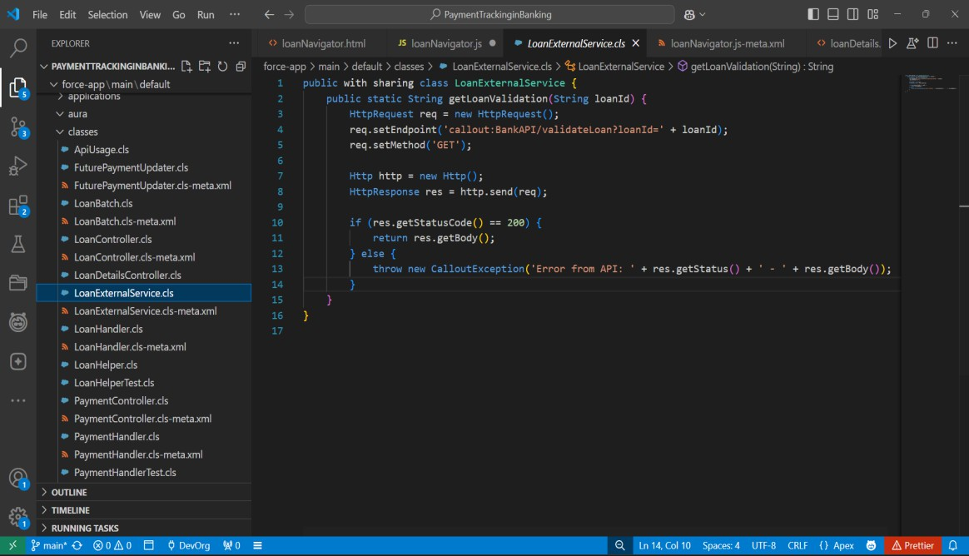            throw new CalloutException('Error from API: ' + res.getStatus() + ' - ' + res.getBody());}}}

# Callouts

* Used when Salesforce sends data to external services.

**RecoveryCallout.cls**

public class RecoveryCallout implements Queueable, Database.AllowsCallouts {

    private Id recoveryId;

    public RecoveryCallout(Id recId) { this.recoveryId = recId; }

    public void execute(QueueableContext qc) {

        Recovery__c rec = [SELECT Id, Loan__c, Amount_Recovered__c FROM Recovery__c WHERE Id=:recoveryId];

        HttpRequest req = new HttpRequest();

        req.setEndpoint('callout:BankAPI/recoveryStatus');

        req.setMethod('POST');

        req.setHeader('Content-Type', 'application/json');

        req.setBody(JSON.serialize(rec));

        HttpResponse res = new Http().send(req);

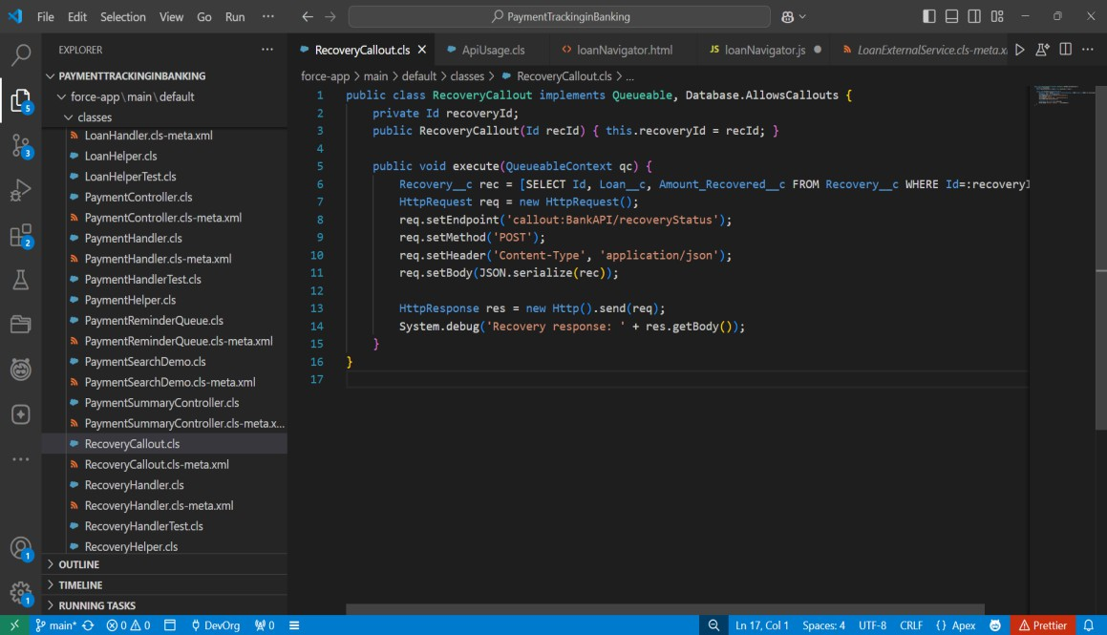        System.debug('Recovery response: ' + res.getBody());}}

# Platform Events

* Publish event when a Payment is Overdue (integrates with external collectors).

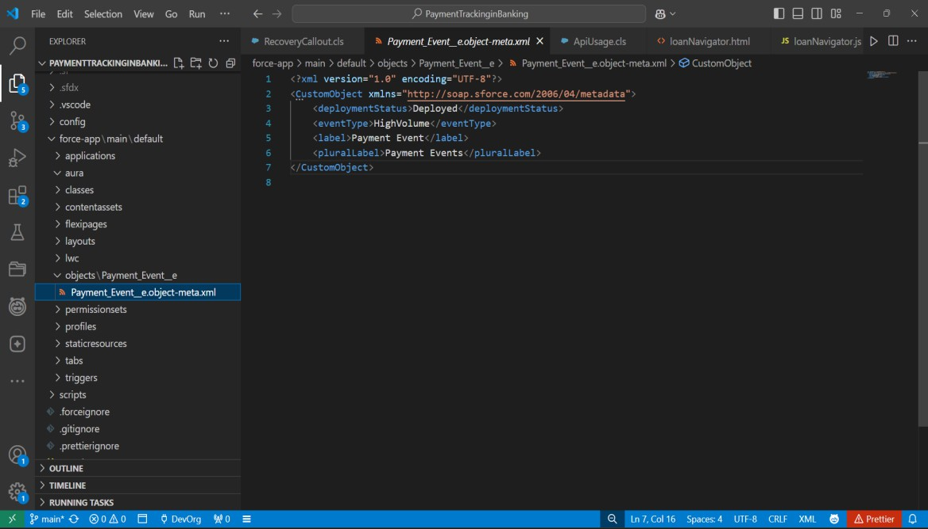

# Change Data Capture (CDC)

* Streams real-time changes of Salesforce records to external systems.
* Any update in Payment_c record can be pushed automatically to reportin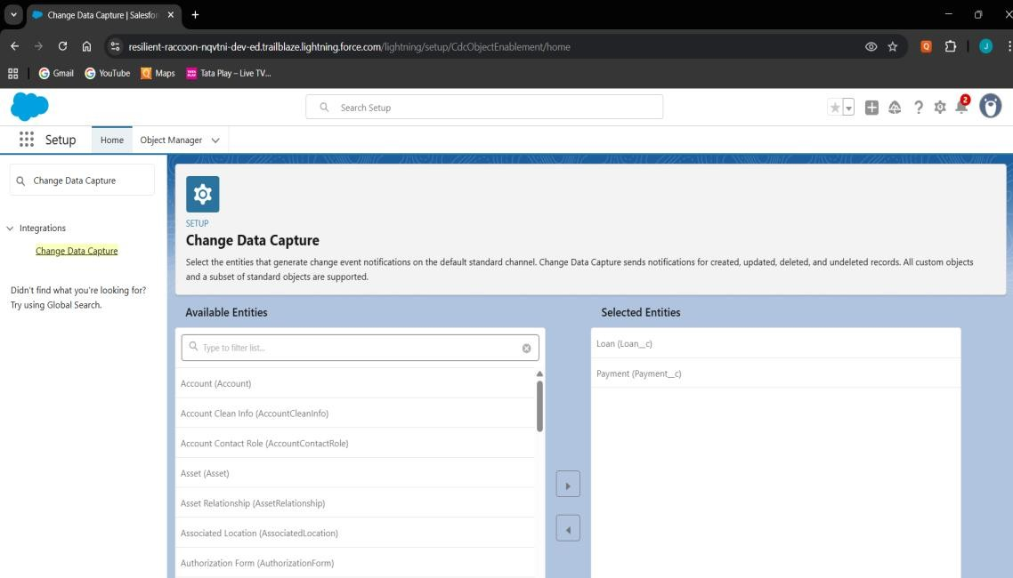g system.

# Salesforce Connect

* ****Provides real-time view of external data without storing in Salesforce.

# OAuth & Authentication

* 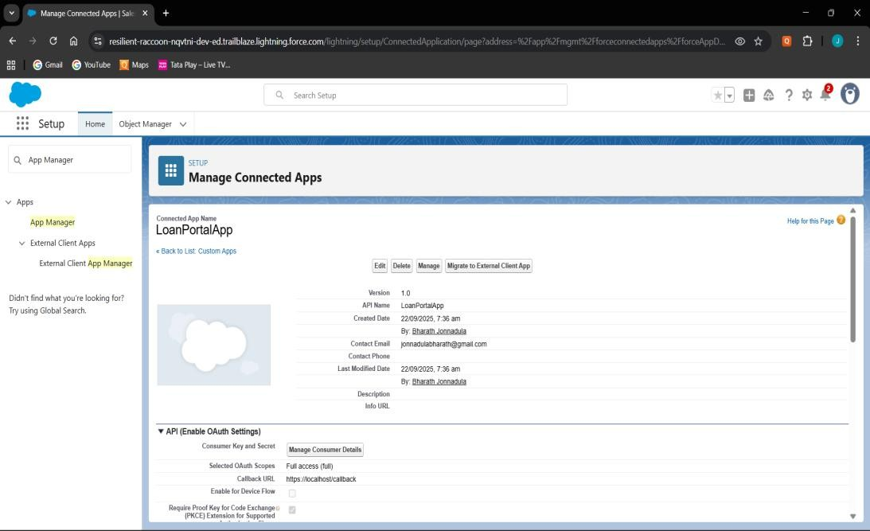Enables secure access for external apps to Salesforce APIs.

# Remote Site Settings

* Required to allow outbound callouts to untrusted domains.
* Add https://api.bank.com as a Remote Site Setting before making callouts.

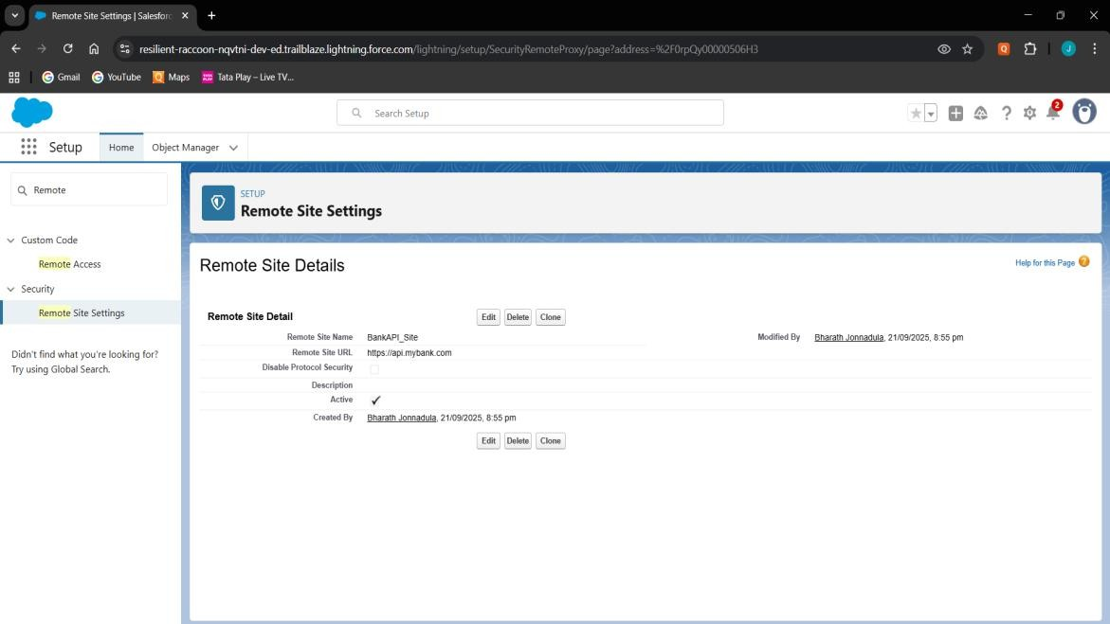

# Phase 8: Data Management & Deployment Data Import Wizard

* Used Data Import Wizard to insert sample data into Loan, Payment, and Recovery objects.

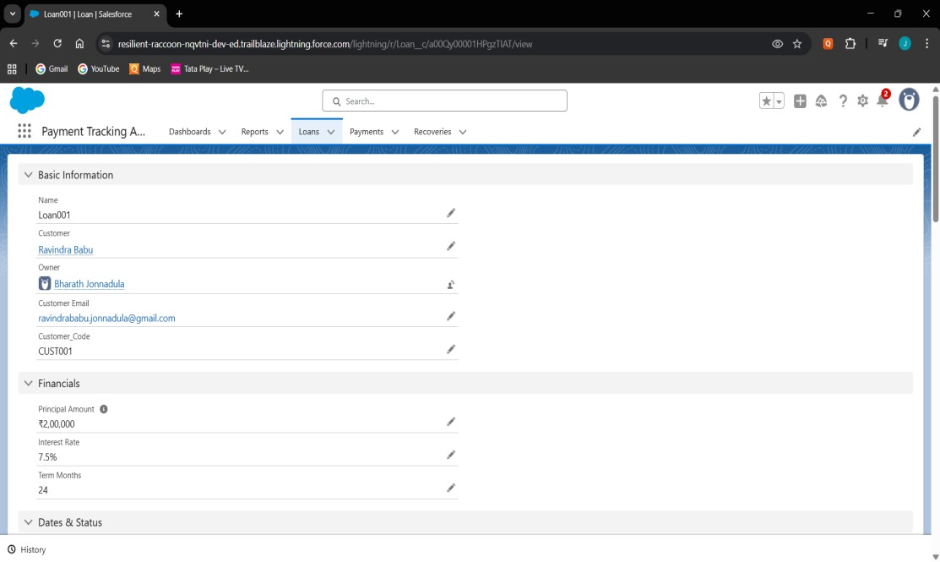

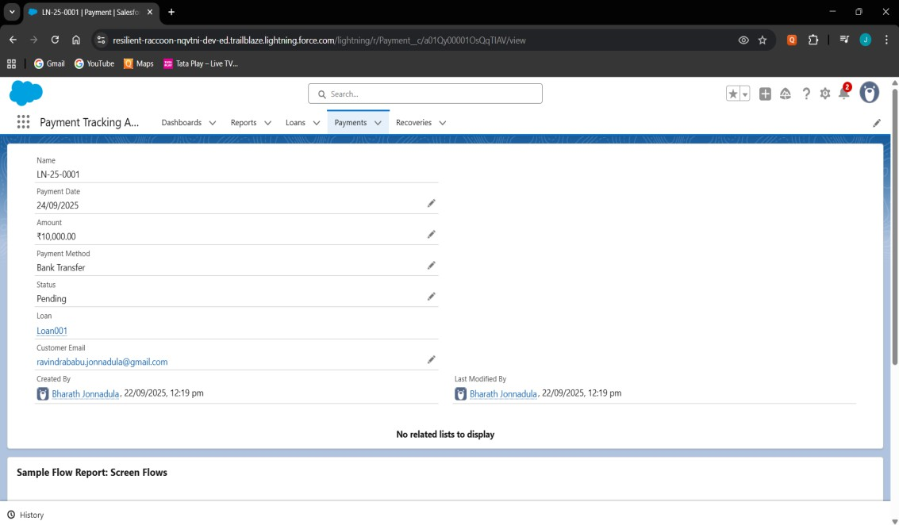

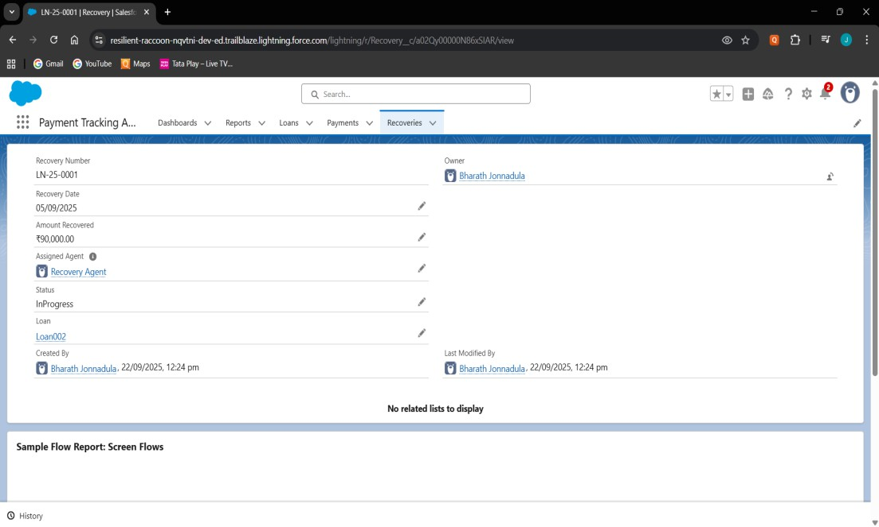

# Data Loader

* Data Loader for bulk upload, but not required since records were limited.

# Data Export & Backup

* Verified Data Export option in Setup for backup.

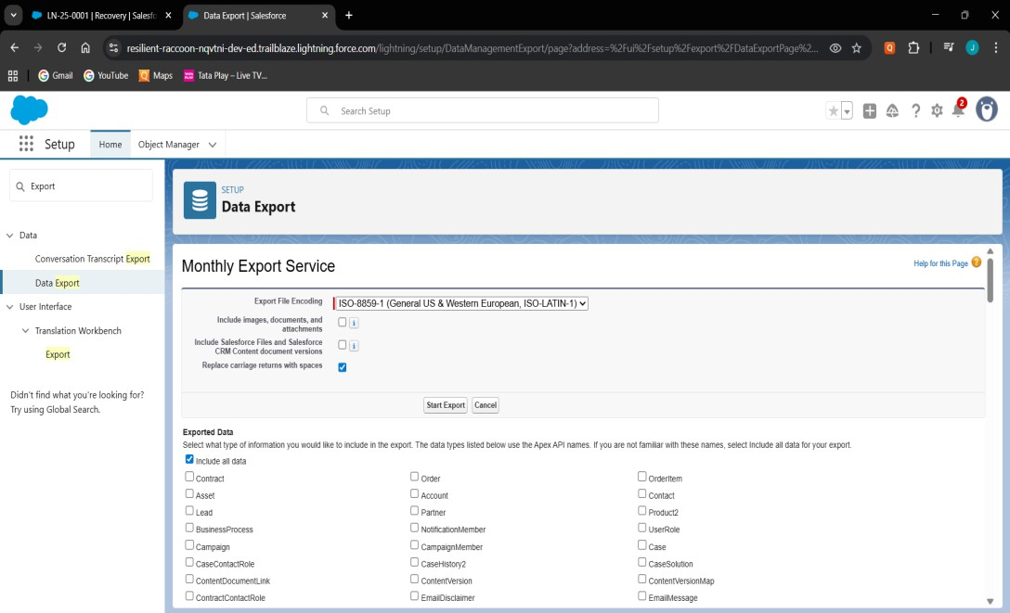

# VS Code & SFDX

* Used VS Code with SFDX CLI for writing and deploying Apex Classes, Triggers, and LWC.
* 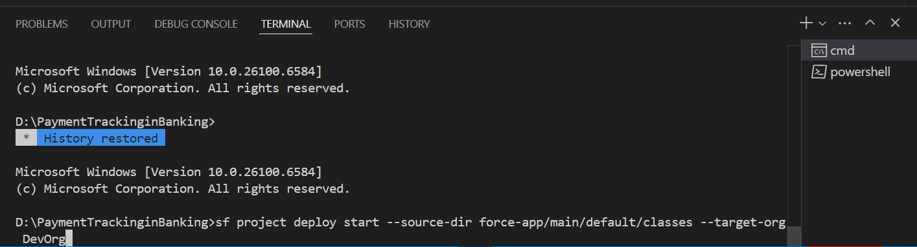Successfully pushed/pulled metadata between local project and Salesforce Org

# Phase 9: Reporting, Dashboards & Security Review

**Reports (Tabular, Summary, Matrix, Joined)**

* + 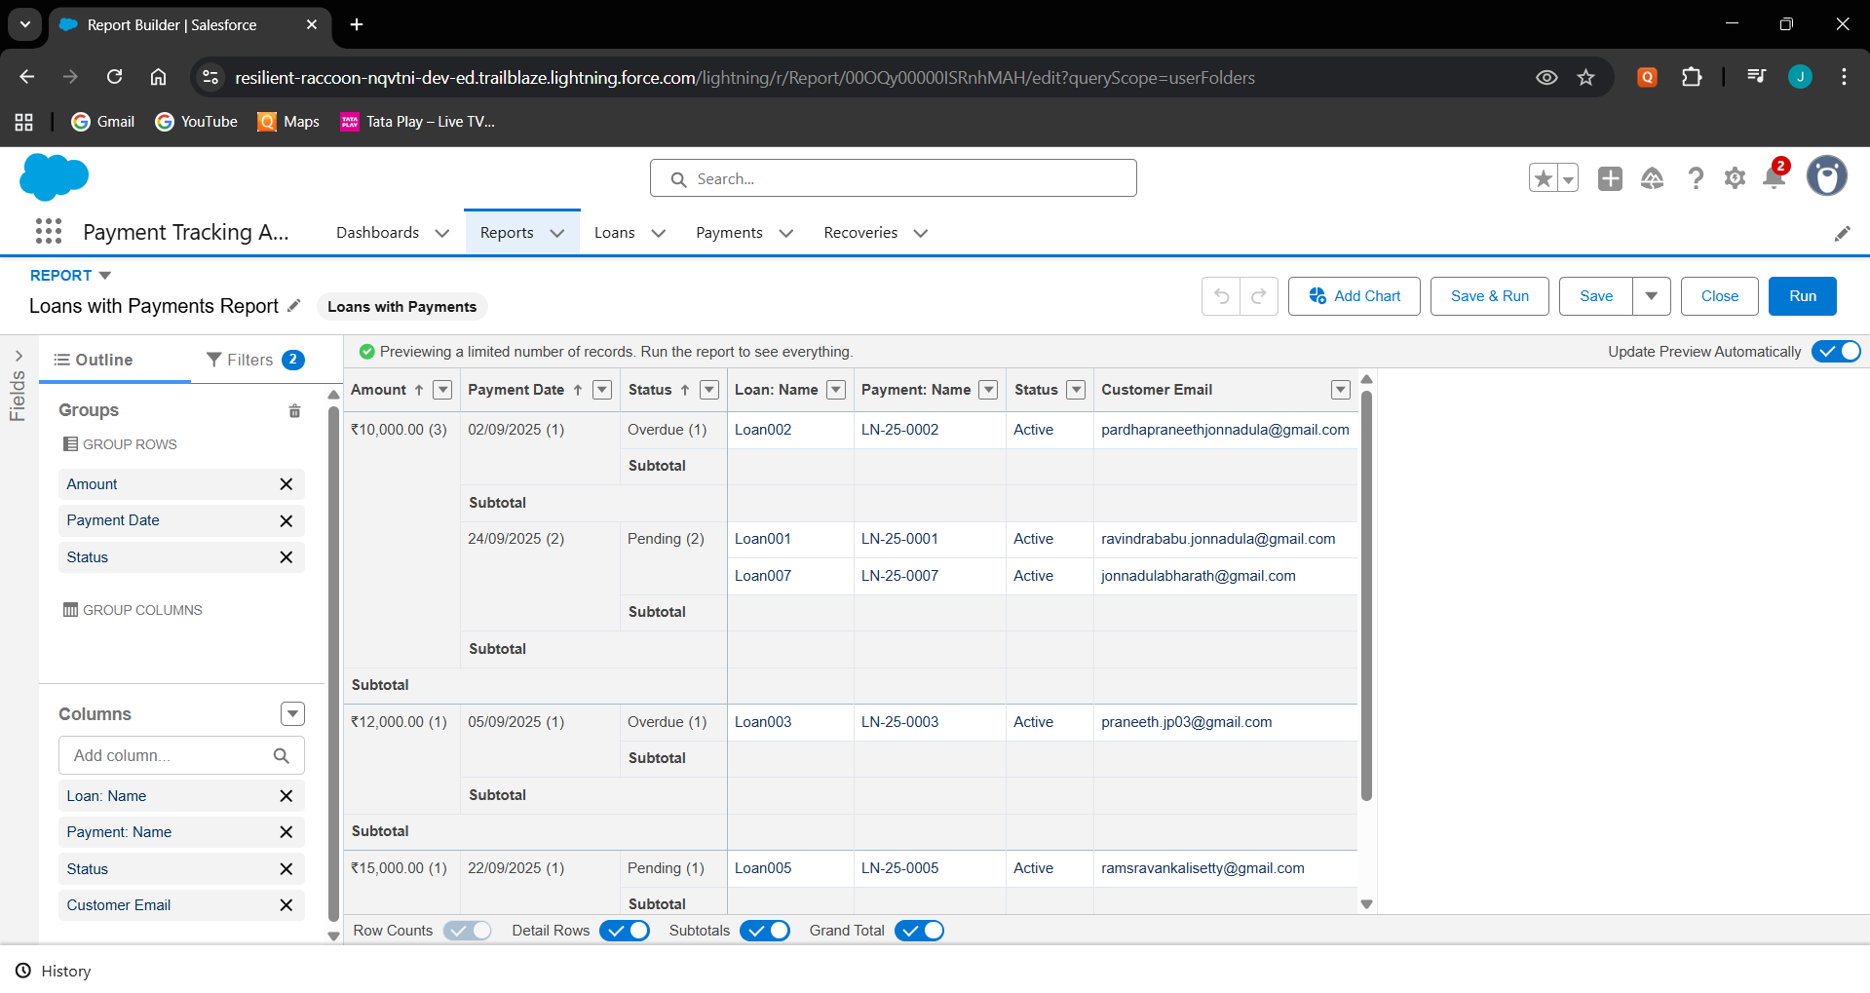Created different report formats (Grouped using Amount, Payment Date, Status and added columns Loan:Name, Payment:Name, Status, Customer Email)

# Report Types

* + Defined a Custom Report Type with Loan__c as the primary object and Payment__c .

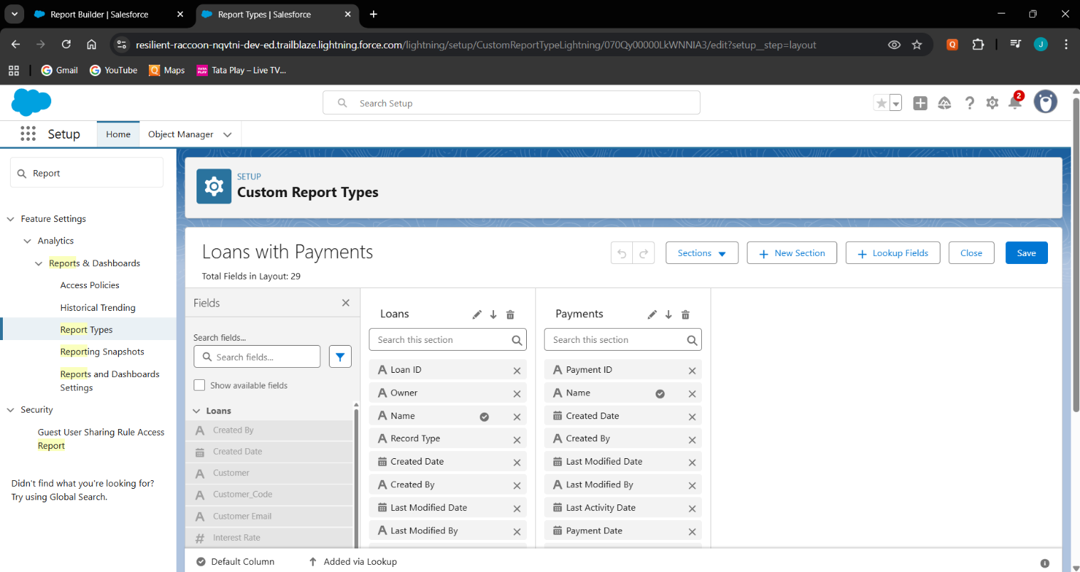

# Dashboards

* + Built a Payment Tracking Dashboard that included widgets like Loan vs Paid Amount.
  + 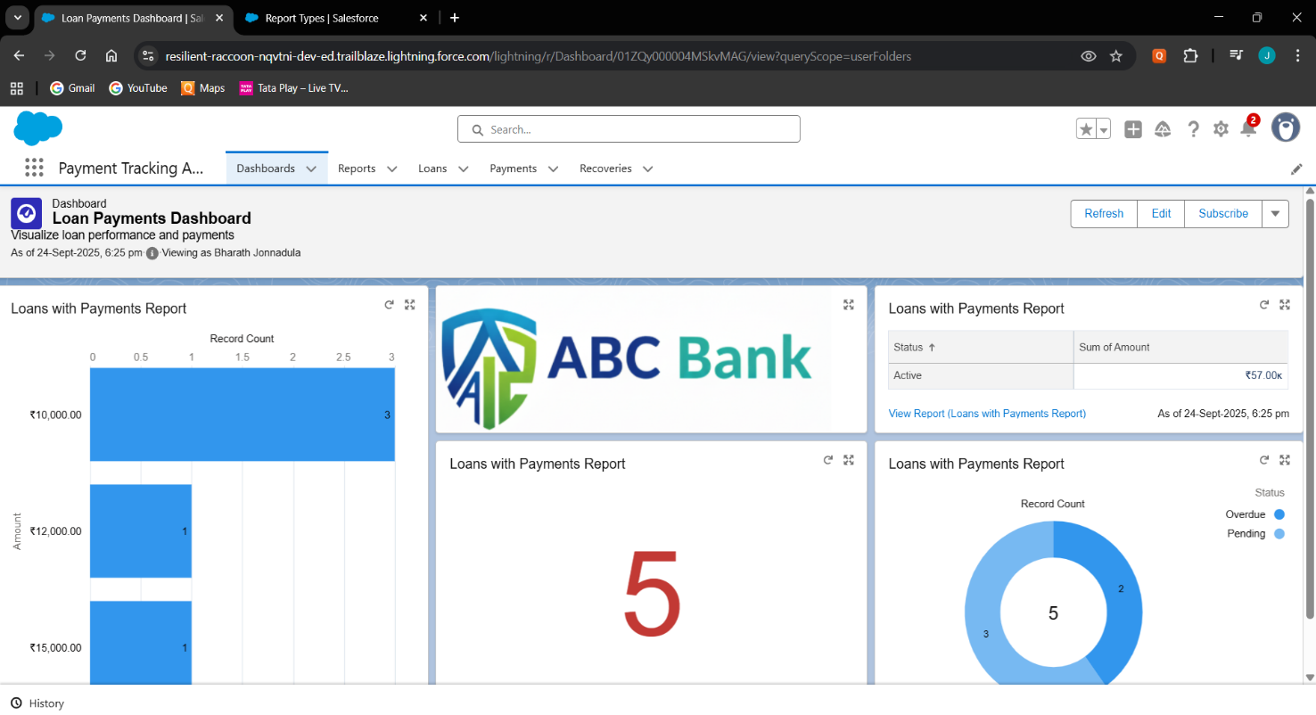Connected each widget to source reports.

# Profiles

* + 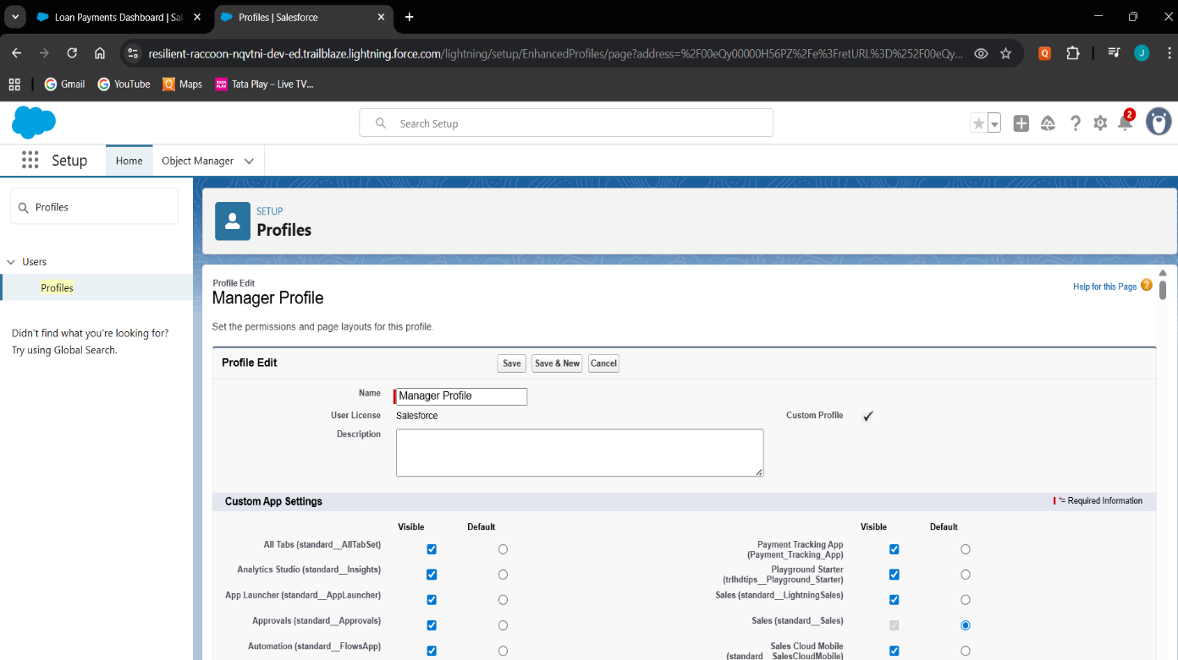Created Manager, Loan Officer, Recovery agent profiles.

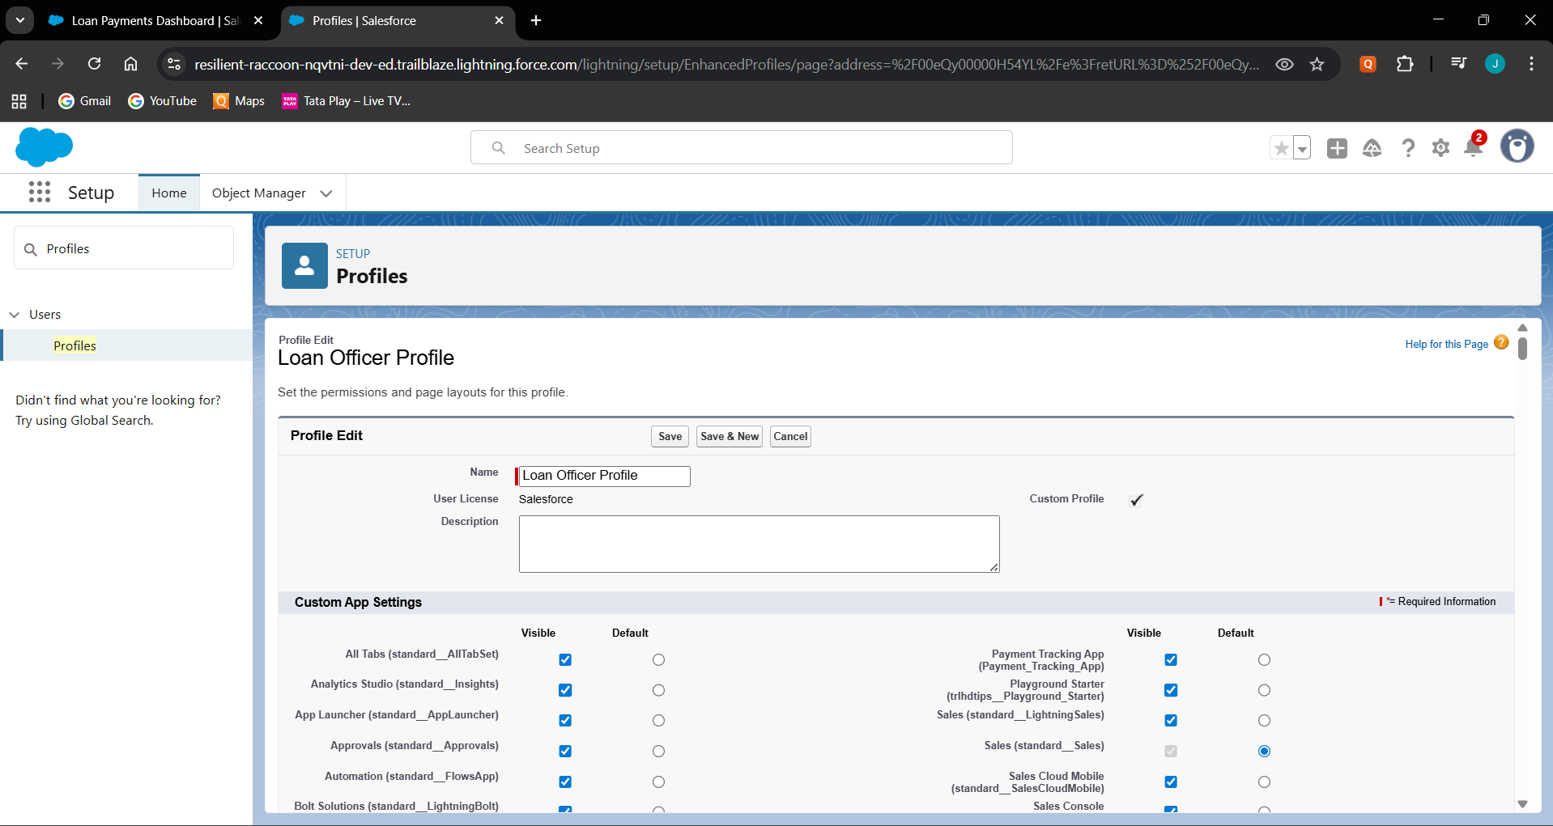

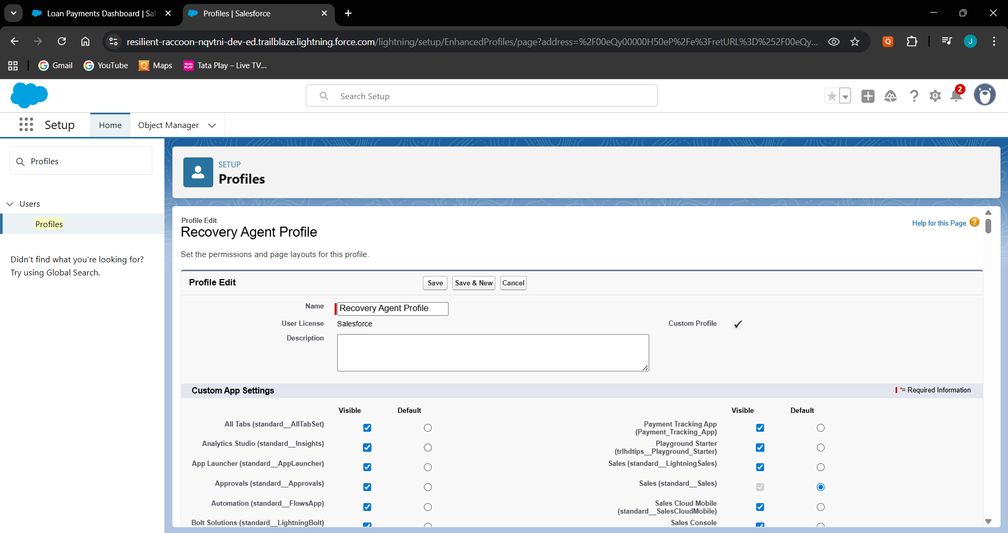

# Roles

* + 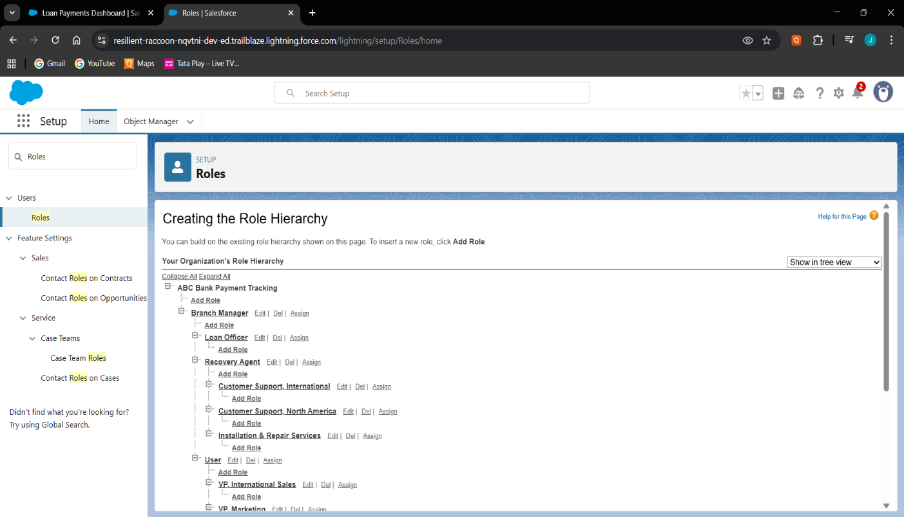Built the role hierarchy of Branch Manager, Loan Officer and Recovery Agent.

# Users

* + 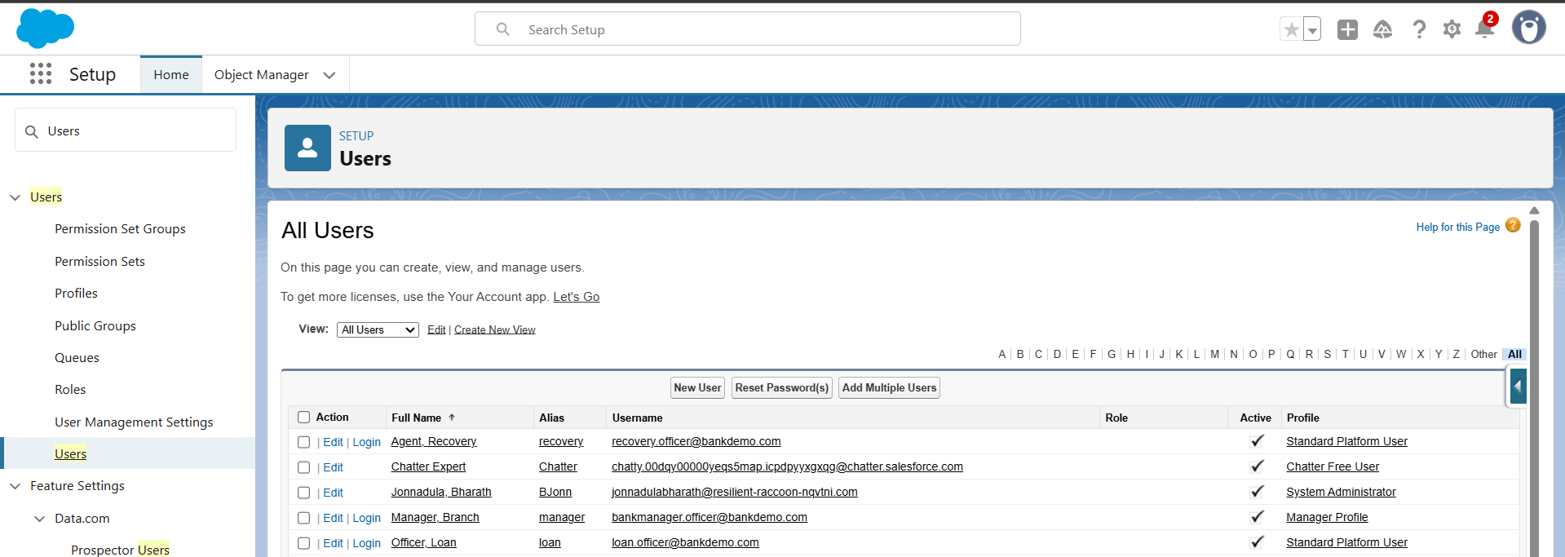Created users (Branch Manager, Loan Officer, Recovery Agent).

# Permission Sets

* + 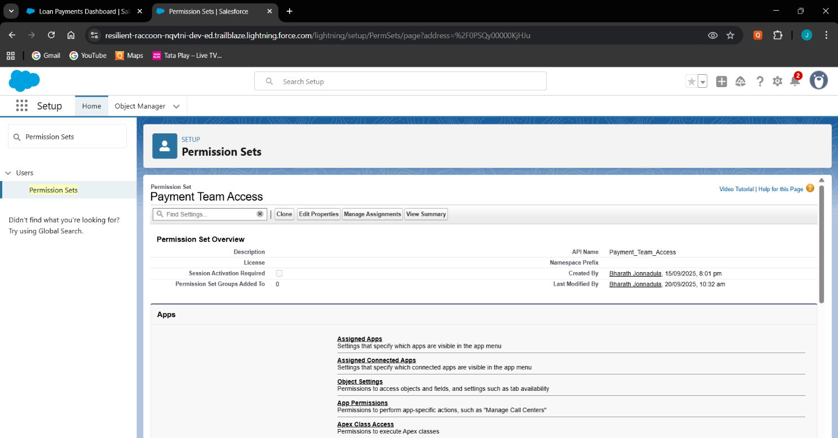Create a Permission Set for payment tracking access.

# OWD & Sharing Rules

* + Set custom objects (Loan, Payment, Recovery) to Private.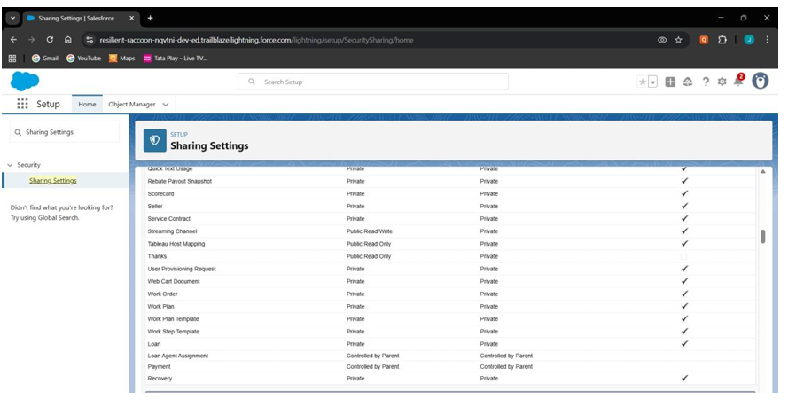

# Sharing Settings

* + 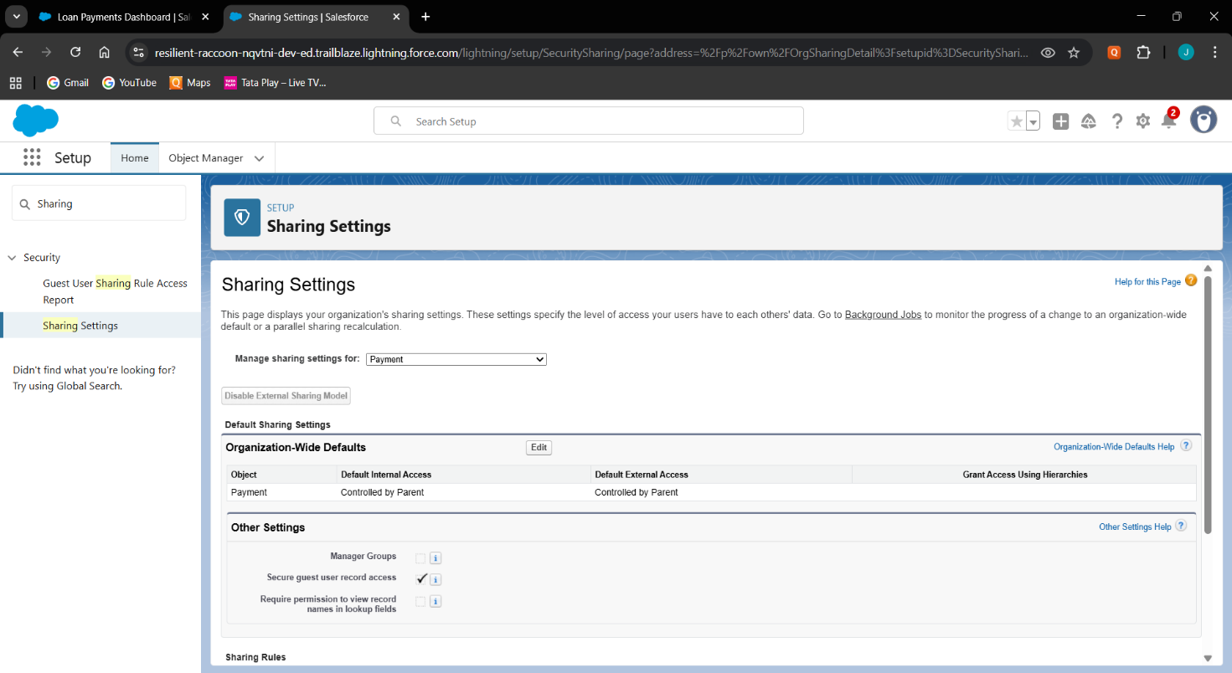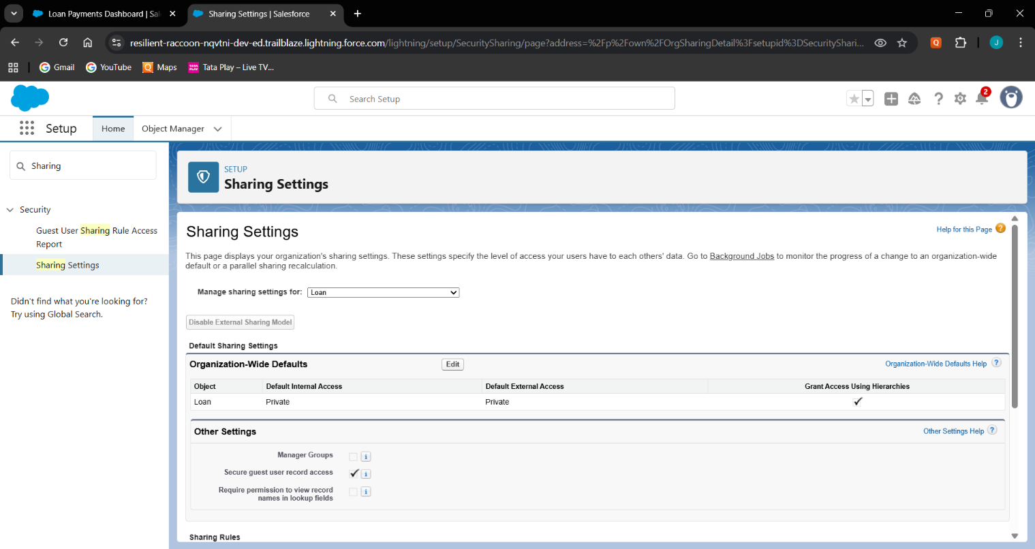Set custom objects to private(Loan, Payment, Recovery).

# Field Level Security

* + Restricted interest rate to view only for manager.

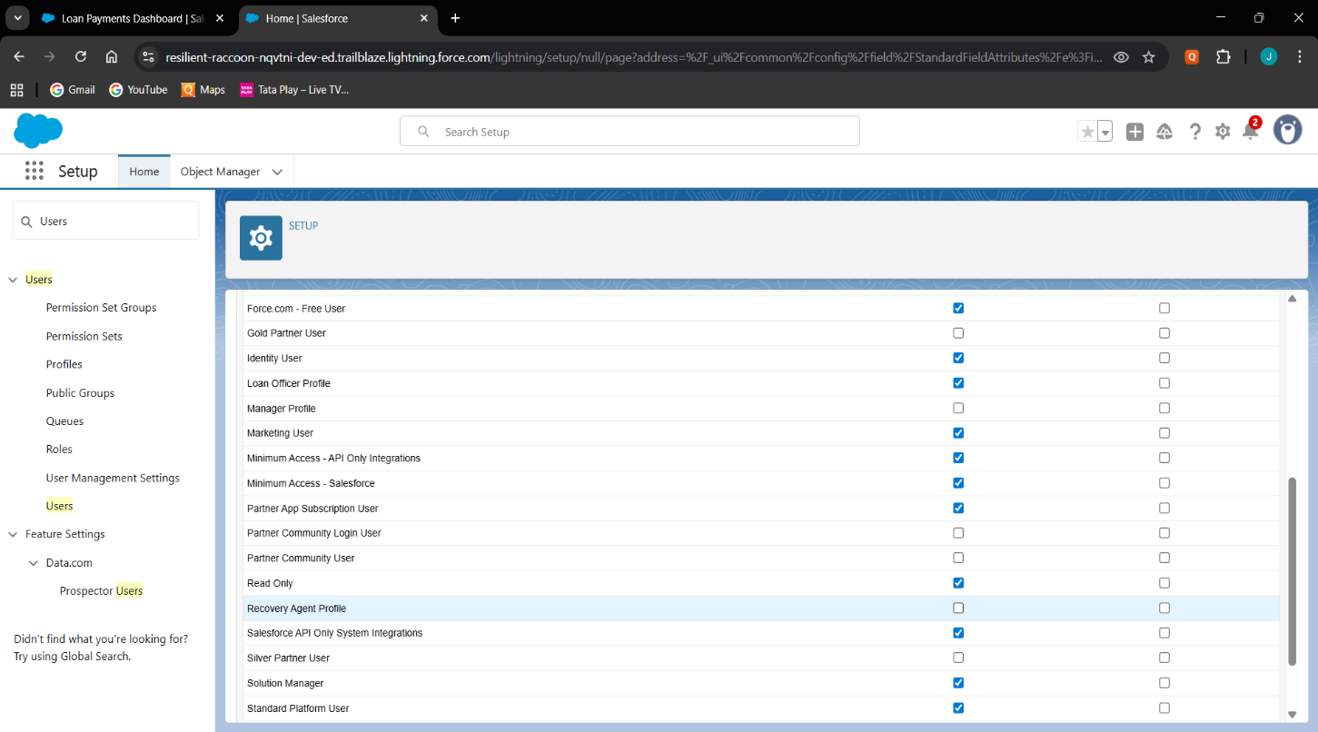

# Session settings

* + 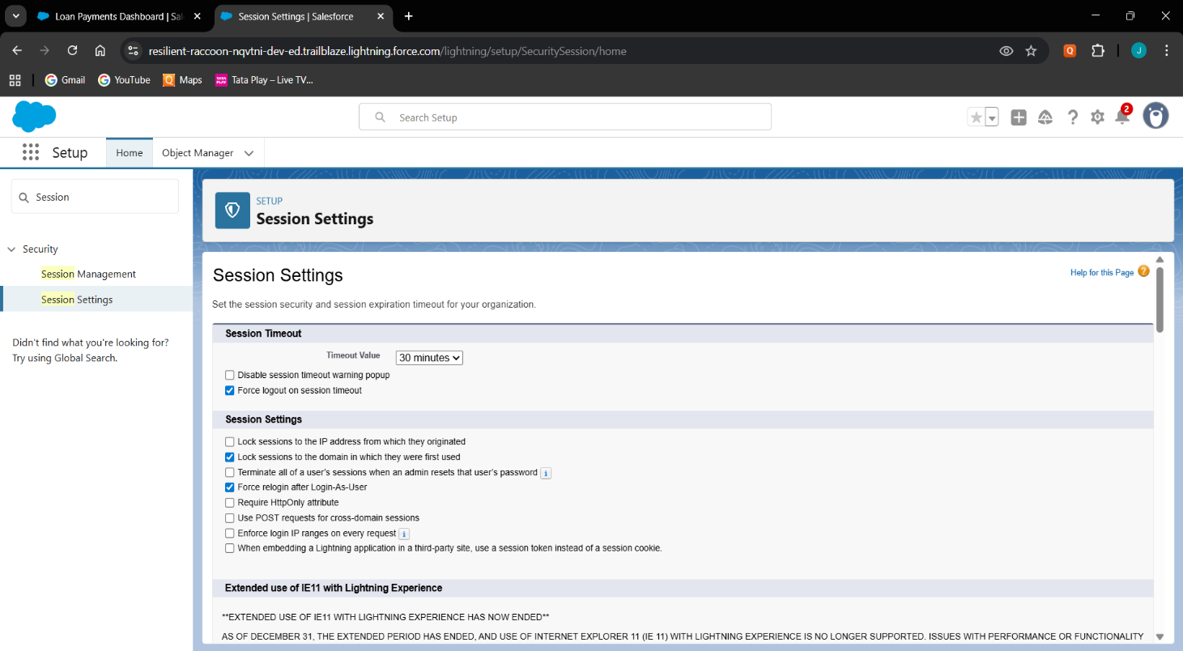Set session timeout for 30 minutes.

# Login IP Ranges

* + 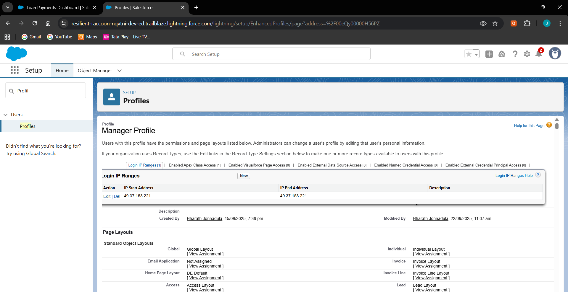Configured login IP ranges for each profile.

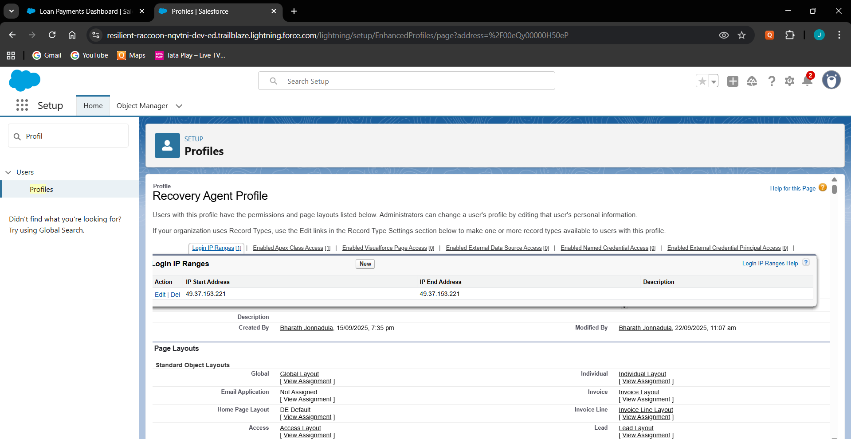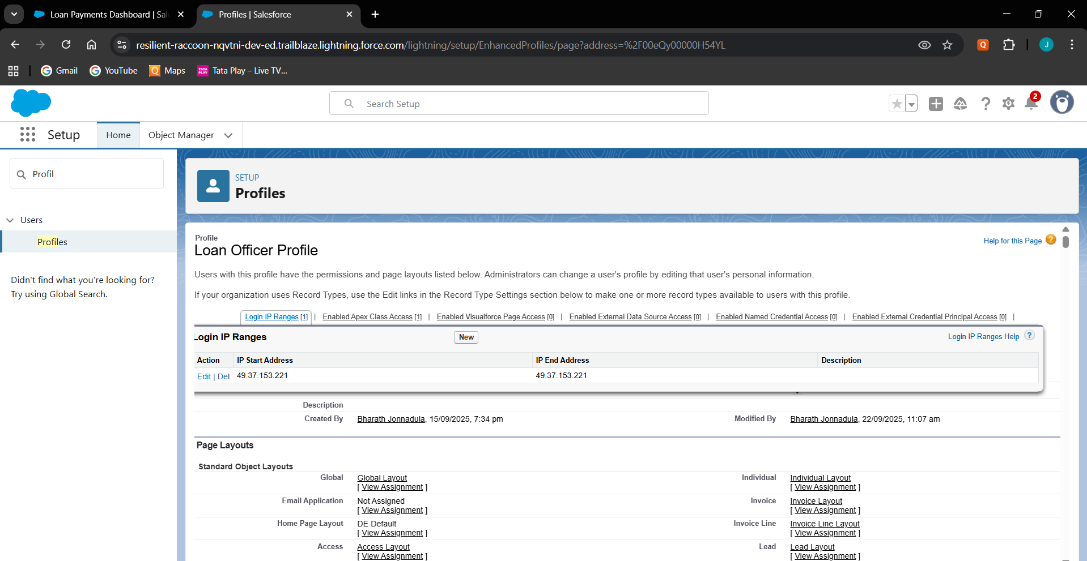

# Audit Trail

* + 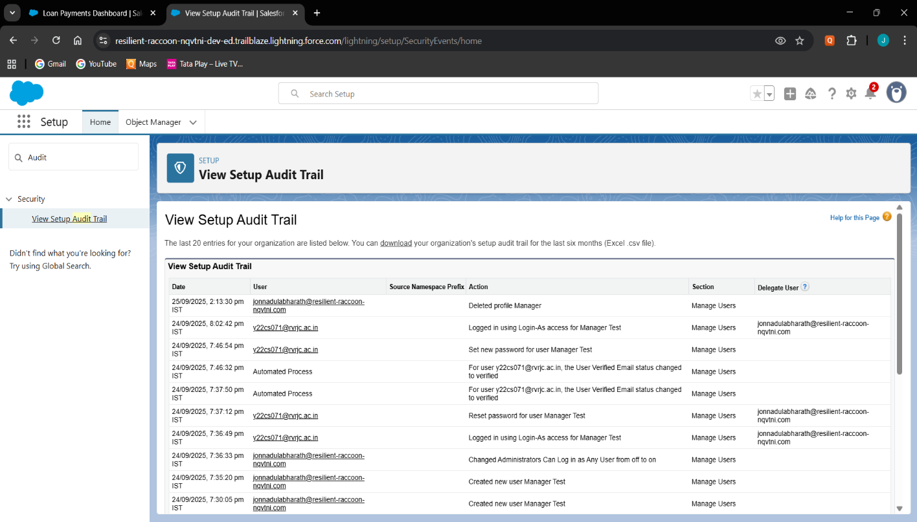Enabled Setup Audit Trail to track all admin-level changes.

# Phase 10: Quality Assurance Testing

# Test Case 1:

# Use case: Verify Loan doesn’t allow negative amounts.

# Input: Creating Loan with prinicipal amount=-1000.

# Expected Result: Error should appear.

# Output:

# Test Case 2:

# Use case: Verify Loan record can be created successfully.

# Input:

# Name: Ravindra Babu,

# Email: [ravindrababu.jonnadula@gmail.com](mailto:ravindrababu.jonnadula@gmail.com)

# Interest rate: 10%, Prinicipal Amount = Rs.100000

# 

# Expected Result: Loan Record created successfully.

# Output:

# Test Case 3:

# Use case: Verify Payment record links correctly to Loan.

# Input:

# Loan: Loan001,

# Amount: Rs.10000,

# Email: [ravindrababu.jonnadula@gmail.com](mailto:ravindrababu.jonnadula@gmail.com) ,

# Status: Pending, Due date: 25-09-2025

# Expected Result: Payment Record created successfully.

# Output:

# Test Case 4:

# Use case: Payment due mail.

# Input:

# Loan: Loan001,

# Amount: Rs.10000,

# Email: [ravindrababu.jonnadula@gmail.com](mailto:ravindrababu.jonnadula@gmail.com) ,

# Status: Pending, Due date: 25-09-2025

# Expected Result: Payment Remainder Email.

# Output:

# Test Case 5:

# Use case: Verify Loans with Payments Report.

# Input: Loans, Payment data

# Expected Result: Report should show Loan: Name, Payment: Name,

# Status, Email, Groupby : Amount.

# Output:

# Test Case 6:

# Use case: Verify dashboard updates after new payment.

# Input: Loans, Payment data

# Expected Result: Loan and Payment summary dashboard.

# Output:

# Test Case 7:

# Use case: Verify Recovery record links correctly to Loan.

# Input:

# Recovery Date: 25-09-2025,

# Assigned Agent: Recovery Agent,

# Status: Assigned,

# Loan: Loan001

# Expected Result: Recovery Record created successfully.

# Output:

# 

# Test Case 8:

# Use case: Verify Duplicate prevention for Loan records.

# Input:

# Name: Ravindra Babu,

# Email: [ravindrababu.jonnadula@gmail.com](mailto:ravindrababu.jonnadula@gmail.com)

# Interest rate: 10%, Prinicipal Amount = Rs.100000

# Expected Result: Error blocking the duplicates.

# Output:

# 

# Test Case 9:

# Use case: Verify Data Export feature works properly.

# Input: Loans, Payments, Recovery

# Expected Result: Receive a mail regarding data export.

# Output:

# Test Case 10:

# Use case: Payment remainder email before due date.

# Input:

# Payment Status: Pending

# Payment Date: Two days before payment

# Expected Result: Receive a mail .

# Output:

# 

**Conclusion:**

The Payment Tracking in Banking CRM successfully demonstrates how Salesforce can be leveraged to automate banking workflows, integrate approvals, and enhance payment recovery efficiency. With features such as custom objects (Loan, Payment, Recovery), automated flows, validation rules, approval processes, and interactive dashboards, the system addresses critical gaps in traditional banking operations. By implementing this solution, banks can ensure timely collections, reduced operational errors, and higher transparency. The project also highlights how Salesforce CRM can be adapted for industry-specific use cases like loan management and financial services. Overall, the solution provides a scalable foundation for banks to modernize customer repayment processes and drive better financial outcomes.